M. V. Bote

40324387

BEng Electrical and Electronic Engineering

ELE3001: Final Year Project Report

Portable System for the Monitoring of Pollutants and Greenhouse Gasses on a Farm

April 2025

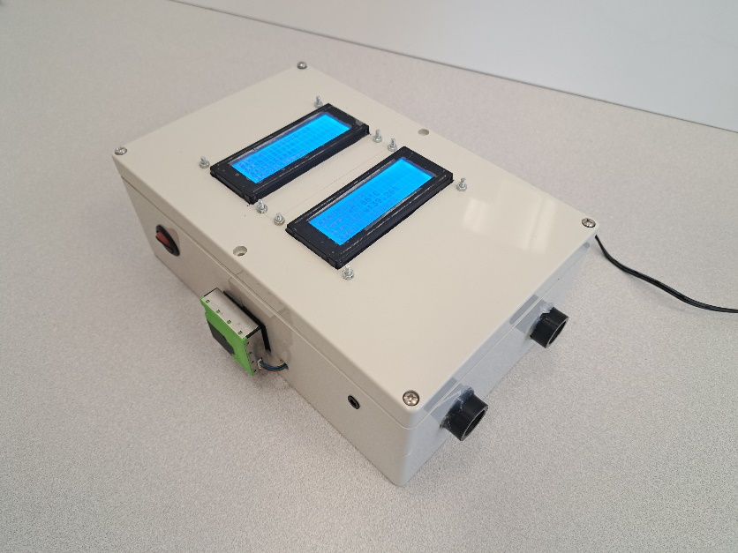

Word count:

# Abstract

# Specification

The original project specification (as pictured in **Appendix 1**) titles this project to be an “*IOT-Based System for the Indoor Monitoring of Greenhouse Gasses and Pollutants*.” The goal being to develop system which encompass the fields of sensor networks, data analytics, and electronics in order to produce a device which can accurately measure concentrations of selected substances in the air and then process these readings into meaningful information for users to act upon.

The specification then stresses the necessity of such a device by referring to statistics released by authorities, such as the World Health Organisation (**WHO**), who have reported air pollution as the *‘world’s leading environmental health risk’* which is responsible for one-third of deaths from strokes, lung disease and chronic obstructed pulmonary disease. Particularly dangerous substances are then spotlighted for their harmful effects; for example, referring to when the UK’s Department of Health and Social Care’s independent Committee on the Medical Effects of Air Pollutants quantified the long-term impacts of Particulate Matter (**PM**) exposure across the UK as equalling 340,000 years of life lost. Such statistics culminate in the specification mandating that the project must, at least, utilise sensors for PM, methane (**CH₄**), carbon dioxide (**CO₂**), carbon monoxide (**CO**), temperature, and humidity. The first four are prevalent and dangerous pollutants, common across a multitude of scenarios, while the latter pair are essential metrics in the perceived air quality and can also directly affect the performance of the gas sensors and so, must be closely monitored.

Finally, the specification concludes by listing the overall objectives of this project in the form of linear goals to achieve in the development of the system; beginning with reviewing the shortcomings of current air quality monitoring systems, then moving on to the development of a custom solution by integrating the sensors mentioned above to an Arduino microcontroller, and lastly, to display and record the readings from the sensors via an IOT dashboard. Extensions were also mentioned to create a more comprehensive solution, through actions such as more in-dept data analysis to understand the readings beyond simply plotting them, and to perform a field test to investigate if the system can perform in practical scenarios.

# Acknowledgements

# Declaration of Originality

I declare that this report is my original work except where stated.

|  |  |  |
| --- | --- | --- |
| Michael Vincent Bote |  | 04/04/2025 |

Contents

Abstract ii

Specification iii

Acknowledgements iv

Declaration of Originality v

1. Introduction 1

2. Project Specialization 1

2.1 Farm Pollutants 2

2.2 Farm GHG Emissions 3

3. State-of-the-Art 4

4. Methodology 6

4.1 Specification Amendments 6

4.2 Overall System Design 7

5. Pollutant Sensing 8

5.1 Sensirion SCD41 8

5.2 Sensirion SPS30 9

5.3 DFRobot CO & H2S Sensors 10

5.4 Alphasense PID-AH 11

5.5 Alphasense IRM-AT 13

5.6 Sensor Selection Themes 17

6. Data Displaying & Recording 18

6.1 Youmile LCD Screens 18

6.2 kwnmobile Micro SD Card Module 20

6.3 DFRobot RTC Module 21

7. Alarm Monitoring 22

7.1 Pollutant Thresholds 22

7.2 Alarm Operation 23

7.3 Alarm Subroutine 23

8. Completed System Overview 25

8.1 Wiring Connections 25

8.2 Enclosing the System 26

8.3 Device Specifications 27

9. Test Procedures and Outcomes 28

9.1 Home PM Test 28

9.2 Gas Boiler test 30

9.3 Farm Test #1 (01 – 03/02/2025) 31

9.4 Farm Test #2 (08 – 12/02/2025) 34

1. Project Timeline and Progress 36

5.1 System Design & Integration (Pre-Interim Report) 36

5.2 Reflection on Progress (Post-Interim Report) 38

# Introduction

Poor air quality, in the form of pollutants and greenhouse gasses (**GHGs**), has been recognised in recent years for the massive threat that it poses to the wellbeing of living organisms and to the health of the environment. As such, the rise in necessity and popularity of air quality monitors for safety and to keep track of GHG emissions have also been observed. Legislation has been put into place following these trends, such as with the legal mandating of carbon monoxide (**CO**) detectors in all rented properties and new builds in England, Scotland and Wales in 2022, though a full decade after it was issued in Northern Ireland **[1]**. On top of these mandated sensors, commercially available sensors for indoor and outdoor monitoring have also risen in prominence, both for normal consumers who are simply conscious about the air in their homes, and for large companies who work in environments where air quality is a major and legal concern, like a mine for example. Government climate initiatives have also imposed guidelines and regulatory caps on GHG emissions, hence, having a monitor to ensure such regulations are being followed has risen in significance.

This report will go through the steps taken by myself in the designing, constructing, and testing of a custom air quality monitoring system. It will follow the chronological order of engineering tasks undertaken, beginning with the design and planning stage, where the purpose and target working environment of the sensor will be clearly defined to aid in the development of a refined and effective for said environment, rather than creating a device which performs mediocrely in a range of settings. At this stage, amendments to the project specification to better align with the planned environment will also be explained in detail. Next, it will explore the processes of assimilating different components to work in tandem with each other, explaining the reason for each component’s inclusion and going through the challenges faced with integration and how they were overcome. Finally, it will present the data collected from a range of tests performed on the device, scrutinizing the effectiveness and practicality of the completed system and assessing whether or not the goals of the project have been met. Suggestions on future tests and areas of improvement will also be identified in this section.

# Project Specialization

A key sector, which would make great use of such a device, was identified by the project supervisor to be a farm. Fragkou et al **[2]** explain that agriculture is a “*common driver for both air pollution and climate change*” because common farm activities, such as using fuel-powered equipment and the life cycle of livestock, produce a range of pollutants and GHGs. Some of these substances are immediate dangers due to their lethality, while the rest pose long term risks to the health of people, animals and crops. For these reasons, a farm was selected as the project’s target environment and below is further research into the causes and effects of pollutants and GHGs on a farm, compiled in order to gain a deeper understanding of particular areas of concern and how to best deploy an air quality monitor on a farm.

## 2.1 Farm Pollutants

A large number of pollutants are commonplace on a farm, these pollutants are hazardous not only to the health of the people working, but will also “*affect plant growth, animal health, and productivity* **[3]**.” As such, monitoring pollutants is crucial not only for health and safety, but also for the financial wellbeing of the farm. For example, the UK’s Agricultural and Horticultural Development Board (**AHDB**) report that respiratory diseases in cattle could cost as much as £82 per calf, and in total costs the UK cattle industry £50 million in a year **[4]**.

One of the most common pollutants, which is also mandated to be included into the project by the specification, is Particulate Matter (**PM**). PM refers to fine dust particles in the air, which are indexed by maximum particle diameter in μm (for example PM10 is a dust cloud of particles which have a diameter of ≤10 μm). These are prevalent in farms due to the large number of activities which release particles into the air: for example, soil disturbances in ploughing, smoke in crop burning, etc. Stewart **[5]** explains the basic effect of exposure to high concentrations of PM10 to be the development of respiratory diseases, such as aggravated asthma or bronchitis, and that as the particles get smaller, their effects become more dangerous due to their increased penetration power, as illustrated in **Figure 1**. This is concerning as PM2.5 and smaller have the ability to bypass the body’s natural defences, like mucus membranes, and infiltrate into blood vessels, increasing the risk of cardiovascular issues.

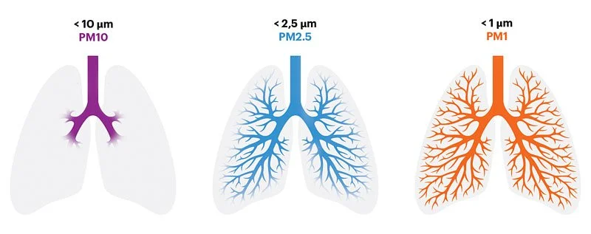

Figure 1 - PM Penetration Power [5]

Another major pollutant concern on farms are slurry fumes. Slurry is a natural fertiliser made from decomposed animal waste, but the decomposition reaction naturally creates a host of dangerous substances as byproducts. A farmer I interviewed explained that slurry tanks are often built underneath livestock buildings for convenience, called an ‘underfloor slated tank’ (shown in **Figure 2**), which becomes worrying especially in the winter when livestock are kept inside for longer, exposing them to the fumes. The farmer interviewed even mentioned news of cattle collapsing in the barn due to the fumes. The most prevalent and dangerous byproduct I identified is hydrogen sulphide (**H2S**), this was inspired by the tragic deaths of professional rugby player Nevin Spence and his father and brother. Nevin and his family were reported by the BBC **[7]** to have been overcome by the slurry fumes leading to their incapacitation and eventual death. Tasker **[8]** explains that, while typically H₂S has a rotten egg smell, “*at higher levels it can’t be smelt, shutting down the nervous system, causing collapse, unconsciousness and ultimately death.*” He wrote his article after two farmworkers were killed by slurry fumes in a farm in England mere months after the Spences’ tragedy, emphasising that the threat of H₂S is very real and more present than most might assume. Loehr et al **[9]** explain that another common byproduct in slurry production are Volatile Organic Compounds (**VOCs**), ranging from GHGs like CH4 to dangerous pollutants like ammonia. Such data emphasise the dangers of slurry fumes in farms and necessitates the inclusion of sensors to observe such emissions.

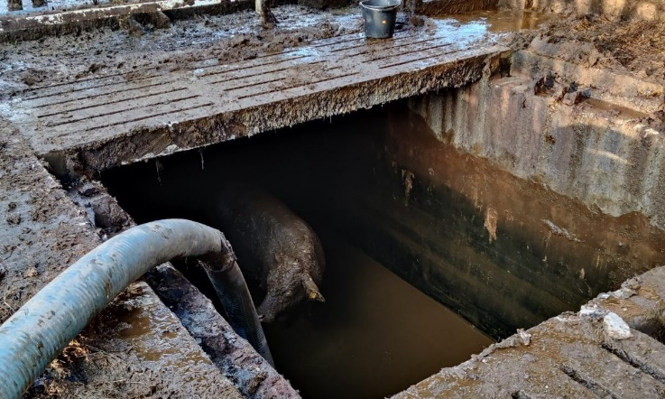

Slurry Vents

Cattle Beds

Underfloor Slurry Tank

Figure 2 - Underfloor Slated Slurry Tank [6]

## 2.2 Farm GHG Emissions

Douglas **[10]** reports that the agricultural industry generates “*21% of all the world’s carbon dioxide (****CO₂****), 53% of all methane (****CH₄****) and 78% of all nitrous oxide emissions globally*.” **Figure 2** illustrates the scale of these figures, showing their significance. This implies that a solution to help farmers monitor their emissions to be more responsible with activities with particularly high GHG outputs would have large positive knock-on effects globally.

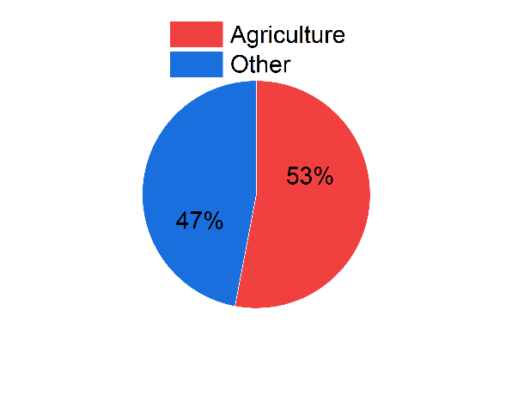 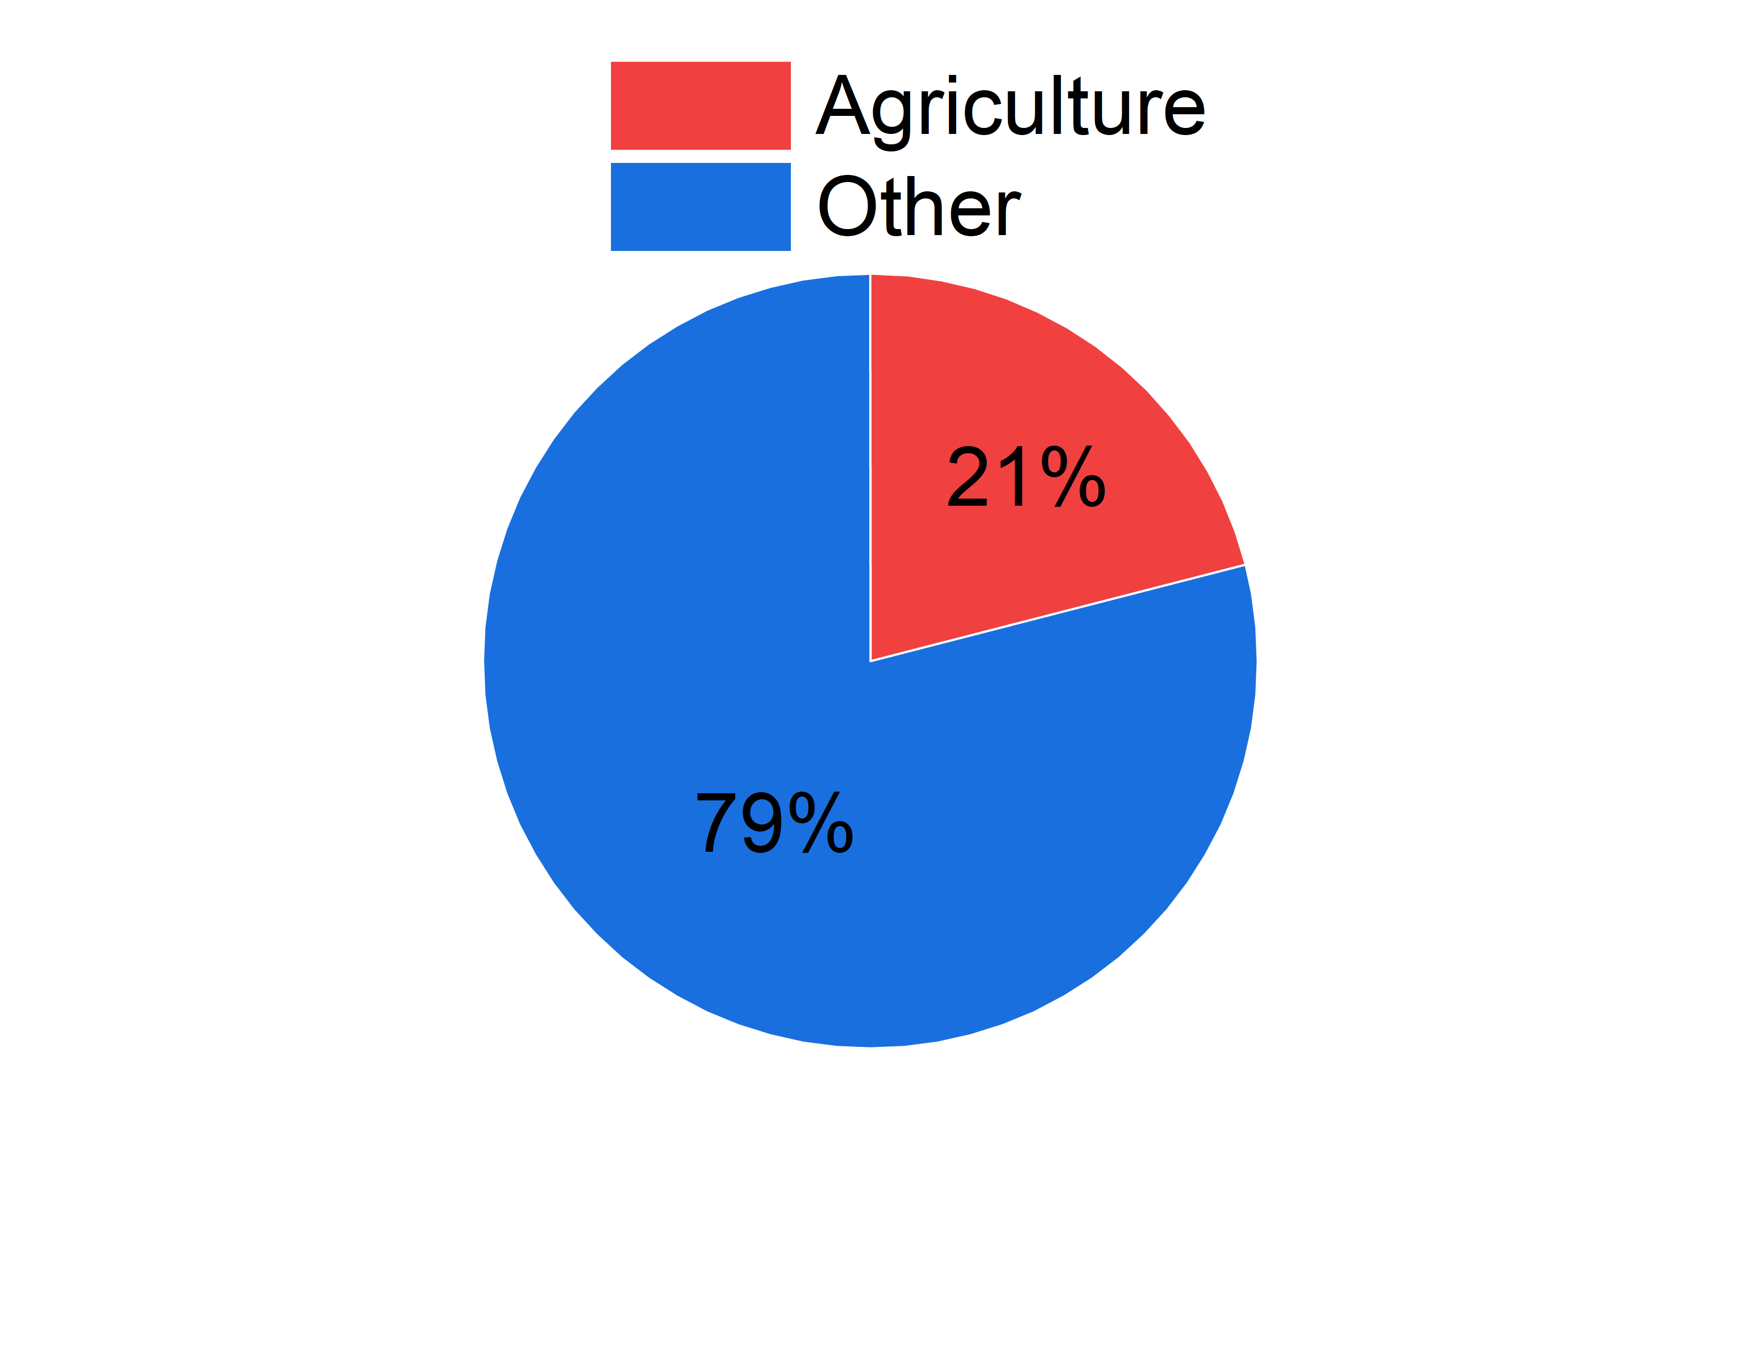

(b)

(a)

Figure 3 – Agricultural Contribution to Global GHG Emissions – (a) CO₂, (b) CH₄

Mann **[11]** explains that CO2 is the “*most significant greenhouse gas*,” and that, while its abundantly produced through natural processes like the aerobic respiration of organisms and decomposition of organic material, there are also natural “*carbon sinks*” (such as plant photosynthesis) which creates a long-term balance of CO2 levels in the atmosphere. However, human activity, primarily in the combustion of fuel, upsets this balance adding as much as 3 Gt of CO2 more than the natural sinks can offset. Many farm activities heavily rely on fuel-powered machinery, which greatly increase their CO2 output (a clear example of which is presented in the test results of **Farm Test 2**). The second and perhaps more pressing concern for farms regarding GHG emissions is CH4. While globally CH4 only accounts for 16% of total GHGs to CO2’s 77%, Browne **[12]** explains that, in terms of Global Warming Potential (**GWP**), CH4 is up to 36-times more potent than CO2. This is extremely concerning as **Figure 2** displays that farms are the cause of over half the world’s CH4 emissions, primarily due to the digestion processes of livestock, especially cattle **[13]**, meaning that dairy farms are of particular concern due to their numerous cows.

# State-of-the-Art

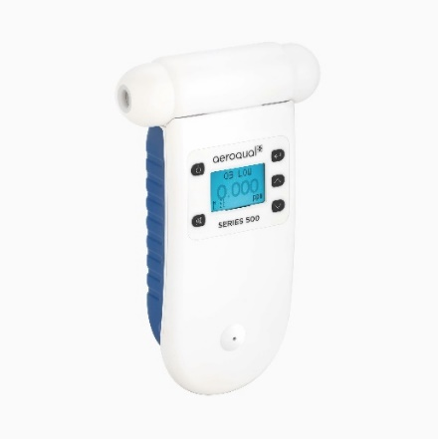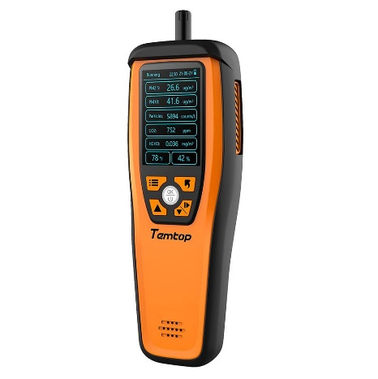**Figure 3** displays two examples of the most popular portable air quality sensors which are on the market right now, together they summarise the shortcomings of the current market.

(a)

(b)

Figure 4 – Portable Air Quality Monitors Currently on Sale – (a) **Aeroqual Series 500** {£1353}, (b) **Temtop M2000** {£142}

Beginning with the latter; the M2000 is extremely limited in its sensing variability, in that it only measures concentrations of CO2, PM2.5, PM10, formaldehyde, temperature, and humidity. While this is a good foundation for air quality readings, **Section 2** demonstrates that these metrics are insufficient for comprehensive air quality sensing on a farm, by missing key substances like CH4 and H2S. **Appendix 2** contains the URL to Temtop’s page going through the specifications of the M2000, where a theme of inefficiency can be observed. Firstly, although the sensing technology utilised is of high quality (such as using a Non-Dispersive InfraRed (**NDIR**) sensor to measure CO2 rather than the less accurate, shorter life-spanned electrochemical sensors), the accuracy of the sensors themselves leaves much wanting; with a measurement uncertainty of 10% for PM and 5% for CO2, making it especially unsuitable for low-level measurement. The device also only has a 6-hour battery life, making it unfit for continuous monitoring. This means that, while it can warn the user of dangerous concentrations, it cannot be used as a long-term aid in managing air quality. An area in which the M2000 displays promise, however, is its data displaying and recording capabilities. It features Thin-Film Transistor (**TFT**) display, producing high quality images (such as the graph shown in **Figure 4**). A drawback to this though, is that it like takes up much power, as seen by the M2000’s 1 A current draw, which alludes to its poor battery life. One offset to the poor battery life on the other hand, is that it can transfer its data measurements to an external device or platform via USB cable, meaning that the user is able to analyse the readings without having to rely on the M2000 being present and powered. In conclusion, while it shows potential, the M2000 is inadequate for farm air quality monitoring and would fail to meet this project’s goals.

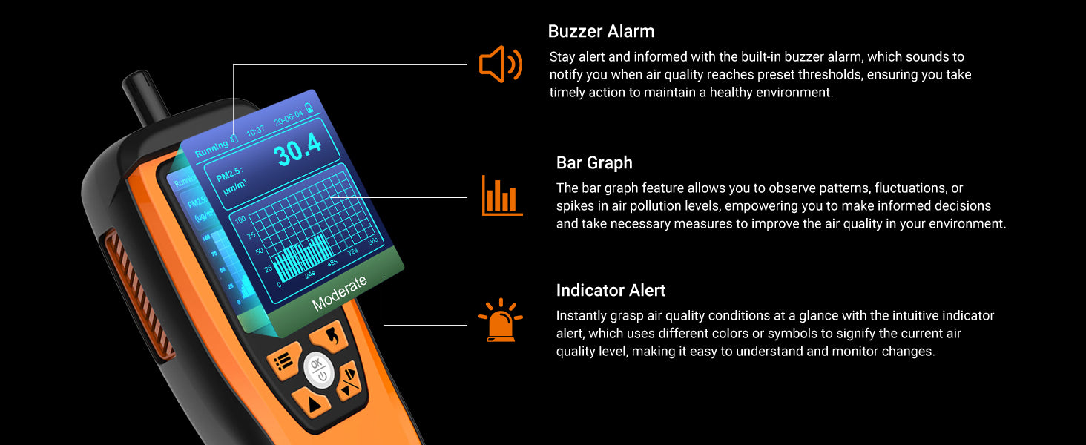

Figure 5 – Temtop M2000 High-Quality Display [ref Appendix 2]

Returning to the Aeroqual Series 500, its drawbacks are immediately obvious with its £1353 price-tag. I presented this expense to friends and colleagues whose family worked in agriculture, and the overwhelming consensus was that, regardless of concerns for air quality, they were not prepared to pay such a price for a solution. For the increased cost, the Series 500 offers a much more comprehensive solution than the M2000 by covering sixteen different substances, including all the main pollutants and GHGs discussed in **Section 2**. However, each pollutant requires a different ‘sensor head’ to record concentrations; this means that it can only record a single pollutant at a time and furthermore the sensor heads are sold separately and have a lifespan of only 2-years, adding to the already significant costs. Upon inspection of the sensor specifications from the Aeroqual website (**Appendix 3**), their capabilities are higher than the M2000 as one would expect for the higher price; for example, there are different sensor heads specifically for high and low concentration, allowing for much more accurate readings and the technology used is NDIR or factory calibrated electrochemical, making for reliable readings. Like the M2000 however, the Series 500’s limited battery life of 8 hours makes it unsuitable for continuous monitoring, but data can be saved onto an external device for separate analysis. Overall, while it offers increased sensing capabilities, the Series 500 shares many of the drawbacks as the M2000 making it unsuitable for the project’s goal of continuous monitoring on a farm, and its massive price-tag only adds to its shortcomings.

# Methodology

## 4.1 Specification Amendments

From the information gathered in the previous two sections, amendments to the system specification were devised by the supervisor and I to tailor the project for operation on a farm. Firstly, as per **Section 2.1**, the inclusion of both H2S and VOC sensors were clearly warranted: H2S because of its status as a prominent and lethal pollutant on farms requires a sensor to keep people and livestock safe, while on the other hand, the VOC sensor would fulfil two roles. Its primary use would be to verify the validity of the CH4 readings, to ensure that the CH4 sensor was not reacting to a different VOC; this was achieved by selecting a VOC sensor which could not sense CH4. Its secondary use was as a general slurry emissions sensor, to validate that the H2S peaks were from the slurry mixing as both readings should correlate.

The next amendment was the substitutions of the IOT dashboard for a physical display and onboard memory. This decision was initially made because previous experience had taught the supervisor that the inclusion of an IOT dashboard often leads the project focus to be on the maintenance of a strong connection between the device and the external server. However, the emphasis of this project was on accurate and reliable pollutant readings, and the location of a farm would particularly make maintaining a strong connection more challenging, diverting time and resources from gas sensing to the IOT. This decision was validated when I performed a survey with friends and colleagues whose families worked in agriculture, asking them if they preferred a physical display or a computer interface, and all selected the former.

## 4.2 Overall System Design

With the specification amendments in place the final system design can be established. The main system operation decomposes into 3 subsystems: Pollutant Measurement, Data Display and Recording, and Alarm Monitoring, **Figure 6** illustrates how the Arduino Mega 2560 microcontroller utilises the three systems in tandem for each measurement cycle.

**Arduino Mega 2560**

**Parameter Sensors**

**Alarm Monitor**

**Data Display and Recording**

Figure 6 – System Operation Overview

A cycle lasts 5 s and begins with the microcontroller communicating with the sensors to return back readings of each parameter. The Arduino will then receive readings for CO2, temperature, humidity, PM10, PM2.5, CH4, VOCs, H2S, and CO; referring back to **Section 3**, this means that my device captures a much more comprehensive view into the farm’s air quality than the M2000, and will do so simultaneously, unlike the Series 500. Once the readings are received, the Arduino then outputs them to the device’s display and to the on-board storage, allowing for both real-time inspection and for reviewing of past data. As the device has a separate storage module, to read the saved files one must physically connect it to an external device, the same as current solutions. Also equivalent to current models is the project device’s alarm monitoring system, where all the pollutants concentrations are fed into an alarm monitor subroutine programmed into the Arduino. In this subroutine, threshold values and time limits are set for each pollutant and if a pollutant remains over a threshold for longer than the accepted time limit, the appropriate alarm will be set off. Finally, the system will run on a continuous 9 V, 2 A DC supply to be plugged into mains, this is to ensure continuous monitoring as, noted from current solutions, a battery source is inappropriate for extended operation. **Sections 5, 6, and 7** will cover the optimisations of each subsystem in further detail.

# Pollutant Sensing

This section will go through the different sensors which form the pollutant sensing subsystem mentioned in **Section 4.2**. It will firstly explain the reason for the sensor’s inclusion over others of the same type, before moving onto the integration process of testing the sensor individually and then as part of the full system. Challenges with implementation will also be explored, with some proving to require more complex processes than others. Finally, it will review the overall themes of sensor selection, explaining how they align with the project goals.

## 5.1 Sensirion SCD41

The first sensor added was the SCD41 by Sensirion (**Figure 10**), which measured CO2, temperature, and humidity. This sensor was inherited from previous students’ undertaking of this project and was initially encouraged by the supervisor for its sensing accuracy.

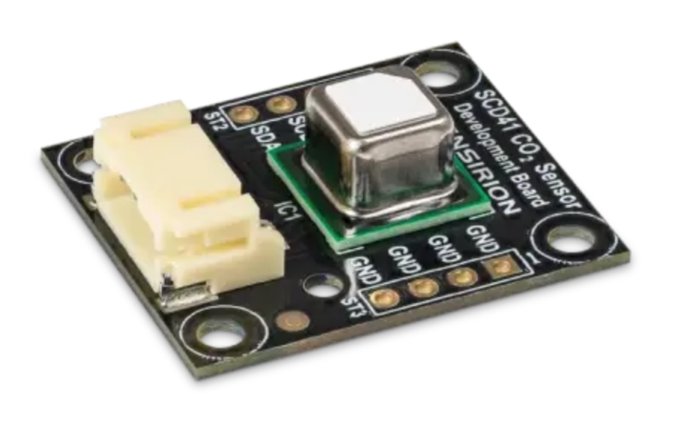

8 mm

24 mm

28 mm

Figure 7 – SCD41 [ref Appendix 4]

Firstly, it utilises an NDIR sensor to measure CO2, which is the most accurate way of measuring CO2, doing so by passing an IR beam through a sample at a wavelength specifically absorbed by the target gas, then measuring how much of the beam passes through and quantifying the gas concentration from that value. This fact was mentioned briefly in **Section 3**, with the Temtop M2000, and a report by González et al **[14]** illustrates the difference in accuracy: González and his team did this by testing a range of sensors for both CO2 and CH4 with known concentrations of the two substances and then plotting graphs of the sensors’ response against the true concentration. The results of this experiment are displayed in their report’s section 3, Figures 16 and 17. The results overwhelmingly show the superiority of NDIR sensors, with there being much variability in the non-NDIR sensors, while the NDIR sensors’ readings are all within 100 ppm of the true concentration. The sensor itself is of a higher class to the one used in the M2000, with its datasheet **[15]** saying that it only has a deviation of +/- 2.5% at low concentrations (400 – 1000 ppm) of CO2, half as much error as the M2000’s. This high accuracy is also demonstrated in the SCD41’s temperature and humidity readings being within 0.8 of a °C and within 6%RH (relative-humidity), respectively.

The integration of the SCD41 was also extremely convenient thanks to the sensor coming pre-soldered onto a custom, Sensirion development PCB, which could digitally communicate to the Arduino via the I2C communication protocol. The connections for I2C straightforward requiring only four connections for power (3.3 V), ground, Serial-Data (**SDA**), and Serial-Clock (**SCL**). Furthermore, Sensirion had also developed software libraries and tutorial examples to operate the SCD41 and had released them for free access within a Github repository (**Appendix 5**). Such amenities made testing the SCD41 extremely simple, able to get readings for the three parameters within minutes.

## 5.2 Sensirion SPS30

Like the SCD41, the SPS30 PM sensor was inherited as the supervisor identified it as of particularly high-quality. As shown in **Figure 11**, it is bulkier than the previous, this is mostly due to its internal fan for its automatic cleaning feature, a necessary addition given the nature of the substance it is measuring.

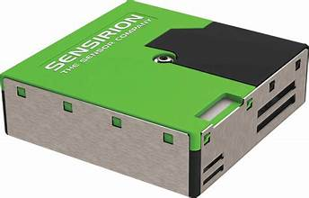

12 mm

41 mm

41 mm

Figure 8 – Sensirion SPS30 [ref Appendix 6]

The SPS30 can read concentrations of PM1, PM2.5, PM4, and PM10 (although only PM2.5 and PM10 were selected to be recorded) to an accuracy of +/- 10% of the true value and does so through optical particle counters which then use laser scattering technology. Essentially, as the internal fan draws in air with PM, a laser is shined through the sample and then a photodiode positioned perpendicular to the laser beam measures the light scattering. Larger particles scatter the light more and vice versa and then the onboard electronics in the sensor analyse the scattering patterns to determine the concentrations of each PM type in μg/m3. This simple but effective sensing method allows for the sensor to be extremely robust due to the straightforward electronics involved, its datasheet **[16]** claims a >10 year lifespan, which is ideal for the environment and target user as farmers do not want a money pit of sensors having to be constantly replaced, like with the Series 500 in **Section 3**.

The integration of process of the SPS30 was largely the same as with the SCD41, with it communicating to the Ardiuno via I2C, and Sensirion also releasing a Github repository (**Appendix 7**) of its C++ libraries as well as example code on how to utilise it. One challenge at the beginning however, was with its input voltage connection. Its datasheet states that it can operate on a supply voltage of 3 – 5 V and, when initially received from the supervisor, it was connected to the Arduino’s 3.3 V supply. Hence, it was assumed that this was the correct connection, but during individual testing it was outputting ludicrously high readings of PM while in a well-ventilated bedroom. There were concerns at this stage that the sensor had become faulty as it was several years old and perhaps a past student had broken it. However, experience I gained while at my year-out-placement, had taught me that, for some components which can run on a range of voltages, the lower bound may be sufficient to turn the component on, but it is inadequate to power the device for full operation. With this conclusion, I then switched the SPS30’s voltage input to 5 V and immediately the problem was solved, and it began outputting reasonable concentrations.

## 5.3 DFRobot CO & H2S Sensors

When selecting sensors for these two pollutants, a compromise had to be made between sensor quality and practicality. Previous iterations of the project had not investigated such pollutants and so, the supervisor could offer no recommendations. H2S had the challenge of a limited selection of choices as it was far less prominent. Oppositely, because of how aware people have become to the dangers of CO, there was an abundance of options ranging from the most basic electrochemical sensors to complicated sensor systems with features far beyond what was needed; hence, I had to filter through to find the optimum choice. Initially, the plan was to utilise alphasense branded sensors, as the VOC and CH4 sensors selected from them had industry-standard accuracy while remaining affordable. However, challenges with the integration of these sensors, as explained in **Sections 5.4 & 5.5**, ruled out this option as deadlines were beginning to loom. This led to the decision to utilise electrochemical sensors from DFRobot’s gravity gas sensor series (**Figure 9**). Electrochemical sensors work by enclosing a chemical which reacts with the target gas to produce a current, and from that magnitude of that, current the concentration of target gas is found. This gives these types of sensors the weakness of lower accuracy because of drift and a shorter lifespan due to the reactant being depleted with time. However, these negatives were offset because sensors in this range are factory-calibrated to be accurate to +/- 10%, i.e. the same as the SPS30. Its specification **[17]** also boasts a >2-year life span, much longer than typical electrochemical sensors, and so, such design benefits compensated for the lower quality sensor.

37 mm

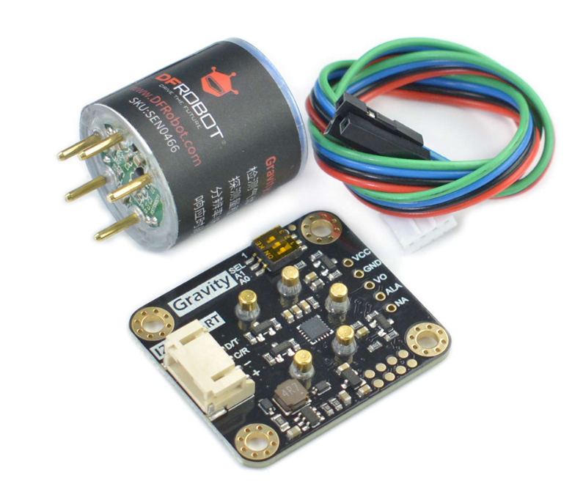

30 mm

32 mm

37 mm

Figure 9 – DFRobot Gravity Sensor [17]

Its convenience of integration was also a major factor in the Gravity sensors’ selection as, like the Sensirion sensors, the Gravity sensors could communicate to the Arduino with the I2C protocol, allowing the Arduino to easily read the concentration of pollutants in ppm digitally. DFRobot had also provided example code to run the sensors in their tutorial **[17]**, and once programmed to an Arduino Uno, readings were immediately received. The only concern for these sensors was the protection of the sensing surface, as it was at high risk of damage either physically or if the reactant was chemically poisoned by too high a concentration of pollutant, precautions to protect the sensing surface are explained in **Section 8**.

## 5.4 Alphasense PID-AH

The last of the inherited sensors was the PID-AH sensor by Alphasense for VOCs (**Figure 10**). This was originally going to be left aside as the sensor worked by ionising VOC molecules with an ultraviolet (**UV**) lamp and then measuring the current generated by the ions to output a voltage corresponding to the VOC concentration. The wavelength of UV light emitted meant that only VOCs with ionization potentials (energy required to free an electron and creating a cation **[18]**) of 10.6 eV or below; however, the sensor had a sensing limit of 40 ppm and the only dangerous VOC it could detect is ammonia, which is dangerous only at far higher concentrations than the sensor limit. The sensor could clearly not be used to sense pollutants in the same facet as the others, which is why the supervisor suggested it be used in the role described in **Section 4.1**, as rather a method to verify the readings of other sensors.

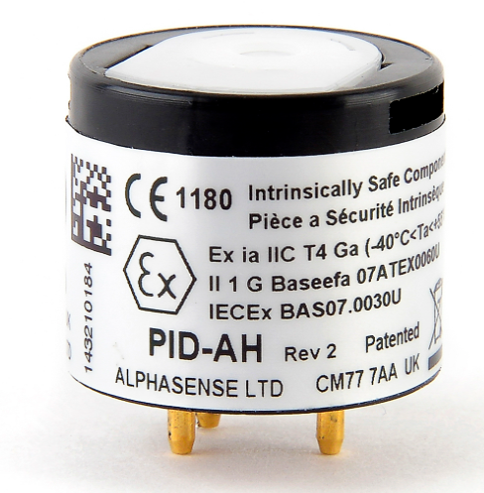

16.5 mm

20 mm

Figure 10 – Alphasense PID-AH [19]

A challenge with interfacing the board was calibrating its reading as it only outputted an analogue voltage signal, which had to be filtered and amplified by an Alphasense-produced PCB for the Arduino to be able to read it stably. To calibrate the signal into an equivalent VOC concentration, I performed an experiment to expose the PID-AH to different, known concentrations of VOCs. From this experiment a graph of the analogue voltage reading against the true VOC concentration could be plotted, and then the scaling factor and offset to convert the output into its equivalent concentration could be calculated.

The experiment setup is as shown in **Figure 11**, the device enclosed into a 22 l plastic bag to control the total volume of air, the plastic bag’s translucent features allowed for me to ensure that the sensor was indeed measuring the reacting to the VOCs via the LCD screens. The VOC sample chosen was an aftershave, because of its high alcohol content of 87%. The aftershave would first be sprayed directly into a plastic cup to gather it up, and then a plastic syringe was used to gather an exact volume, which would be dispensed into a second cup and then placed in the plastic bag beside the sensor. As the volume of alcohol was precisely known along with the total volume of the testing space, the concentration of VOCs in %vol could be easily calculated and then converted to PPM.

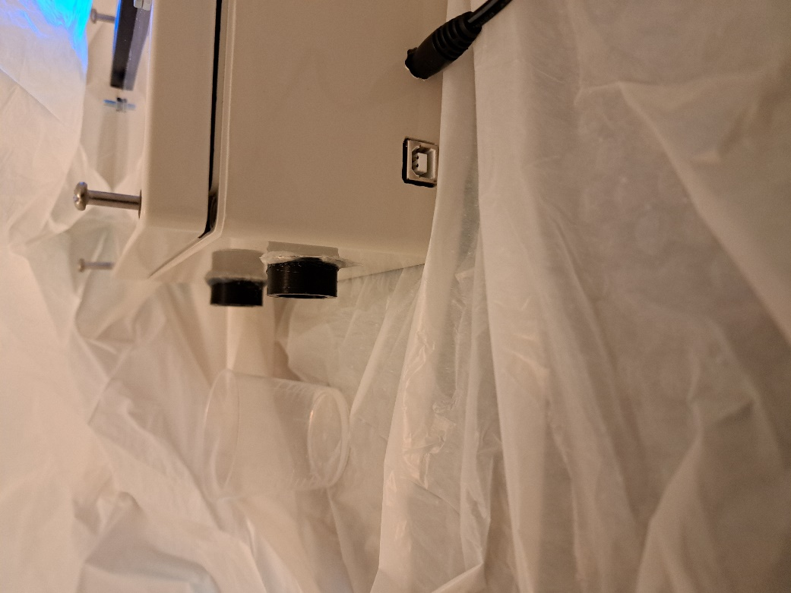

PID-AH

VOC Sample

Figure 11 – PID-AH Calibration Experiment Setup

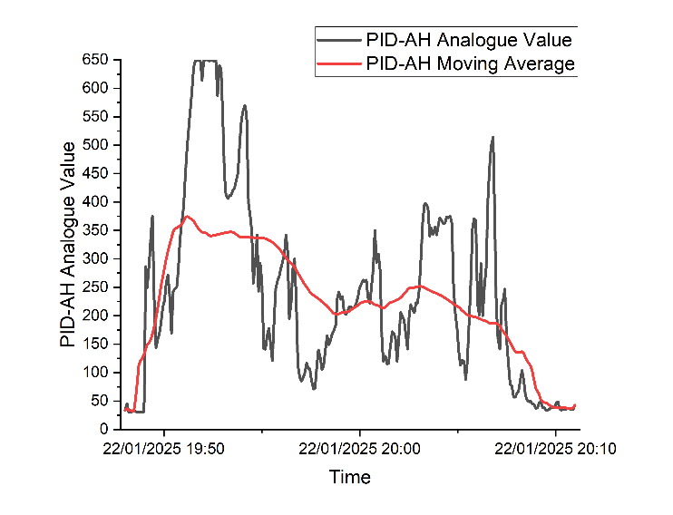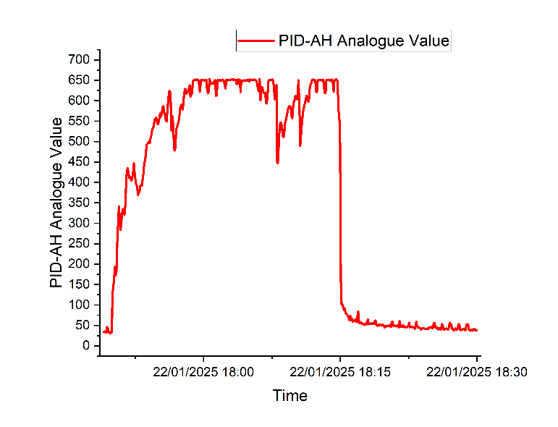**Figure 12** displays the results at two different volumes of substance: **(a)** 1 ml of aftershave, which equates to 45.5 ppm of VOCs, and **(b)** 0.5 ml of aftershave, equating to 22.7 ppm of VOCs. The first take away is that, with both graphs, a baseline reading of ~35 was observed before the VOCs were introduced and after it had settled. This exposed the required offset of 35. Next, for the 1 ml test, the VOC concentration surpassed the PID-AH’s maximum detection limit, and a corresponding plateau is observed in the results, showing that the maximum output equates to an analogue voltage of 650. Taking account for the offset, the sensor output range of the device calculates to an analogue voltage reading from 0 to 615, with 615 equating to 40 ppm of VOCs or more. To confirm this conclusion, the experiment was repeated with exactly half the concentration of VOC, which should output a value around 308 plus the offset. **(b)** displays, that unlike the flat plateau at the maximum, there was much fluctuation at this concentration; however, when one plots a moving average, taken every 100 samples, the plot for the average runs close to exactly as expected with it beginning around 350 and falling off as the VOCs disperse. This confirms the conclusions from the first experiment, validating an offset of 35 and a scaling factor of 0.065. **Equation 1** illustrates how the scaling factor and offset were used as a formula to convert the analogue output into the VOC concentration.

(a)

(b)

Figure 12 – PID-AH Experiment Results – (a)1 ml, (5) 0.5 ml

*Equation 1*

$$VOC Conc. =\left(Analogue Output-35\right)*0.065$$

## 5.5 Alphasense IRM-AT

The final sensor integrated was the IRM-AT CH4 sensor (**Figure 13**). This sensor was actually selected before the DFRobot sensors, however, it was during its lengthy integration period where the decision was made to veer away from the using Alphasense sensors for H2S and CO, as mentioned in **Section 5.3**. This sensor was selected as it was one of the few CH4 sensors which utilised NDIR measurement rather than electrochemical, meaning it was far more accurate (+/- 0.5 %vol for low-level readings **[20]**) and stable than most on the market while remaining affordable. Another reason for its choice was that Alphasense are a UK-based company, leading to a shorter lead time than with other NDIR sensors from EU-based manufacturers. One sensor which was almost chosen over it was the SJH-5 NDIR sensor by Cubic (**Appendix 9**), because of its digital output making integration simpler. However, challenges such as having to make a custom Arduino library to operate it, its much higher cost, and longer lead times made the IRM-AT the more practical option.

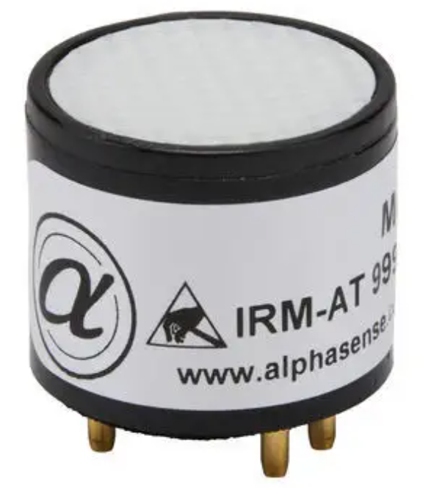

20 mm

16.5 mm

Figure 13 – Alphasense IRM-AT [20]

The IRM-AT had the same problem as the PID-AH in that its analogue voltage output required a PCB to filter and amplify the signal so that it could be read by the Arduino; only for this sensor, Alphasense had yet to release an integration PCB and so, I had to design and manufacture one myself. Its output was actually more complicated as, rather than having only a single channel corresponding to the gas concentration, the IRM-AT had two output channels: a reference and a detector output. At base conditions, with no CH4, the two should be equal but, as the gas concentration increases, the detector output decreases, and it is the growing difference between that two channels that represents the concentration of gas. This task was made much easier thanks to the suggested schematic (**Figure 14**) by Alphasense, which denoted recommended components and circuits. The KiCad PCB design software was then utilised to create the PCB design (**Figure 15**) and the website SnapEDA was used to source the component footprints for the most accurate layout. Finally, the technicians on the Ashby 9th floor laboratories manufactured the completed PCB design and then I was able to solder all the components by hand and could begin testing the sensor.

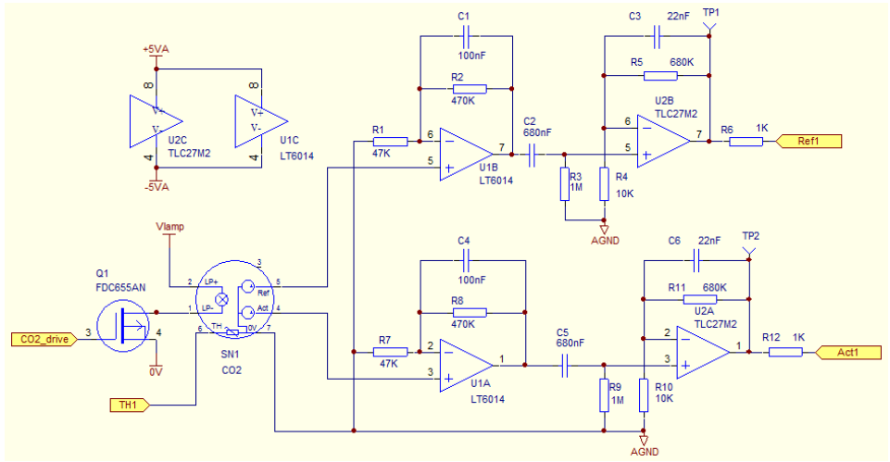

Figure 14 – IRM-AT Integration PCB Schematic

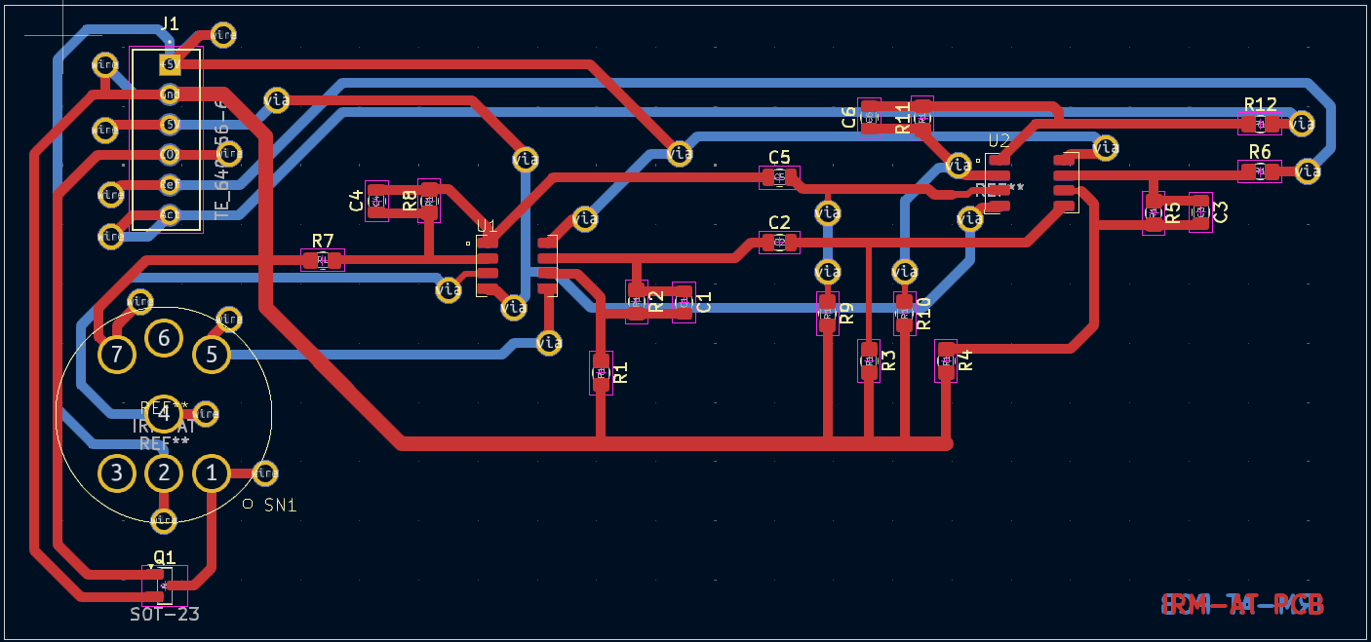

Figure 15 - IRM-AT Integration PCB Design

The initial tested found extremely erratic outputs for both the reference and the detector, jumping between analogue voltage readings of 0 up to over 800. When the outputs were investigated with an oscilloscope to observe the signal, the waveform in **Figure 16** was found. As one can see, the output is a harsh square wave swinging from -750 mV to 3.5 V, at a frequency of roughly 10 Hz. This signal explained the high fluctuations of the output values. From this reference, two observations were made which led to the solution: the waveform’s frequency and its amplitude. Firstly, its frequency, the Arduino Uno controlling the sensor was programmed to specifically operate at 3 Hz, as suggested by Alphasense, meaning that the switching signal was being interrupted for at least one of the active components. More importantly however was the amplitude: for proper operation, the operational amplifiers (Op-Amps) needed supply voltages of +5 V and -5 V, the positive coming from the Arduino and the negative coming from the negative voltage supply made by connecting a 9 V battery in reverse across a -5 V voltage regulator. Given this setup, it was peculiar that the troughs of the output signals were so much shallower than the peaks at ~750 mV to 3.5 V. This prompted an inspection of the negative voltage supplies of the Op-Amps from which, it was discovered that one of the vias which connected the Op-Amp U1 to the -5 V track had a ‘dry joint’ (solder on the surface only but was actually open circuit). Once the via was soldered properly the readings immediately stabilized, and the final output waveform is as in **Figure 17**, having equal peak and trough amplitudes of ~300 mV at a frequency of 3.66 Hz.

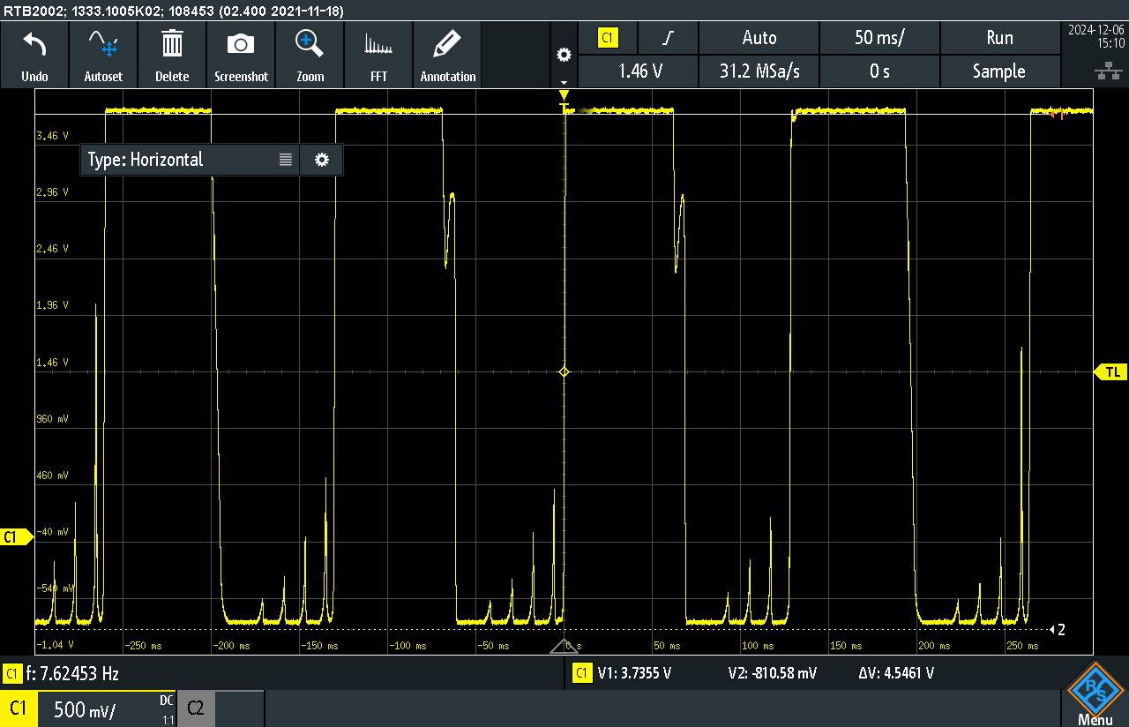

Figure 16 – IRM-AT Initial Output Waveform

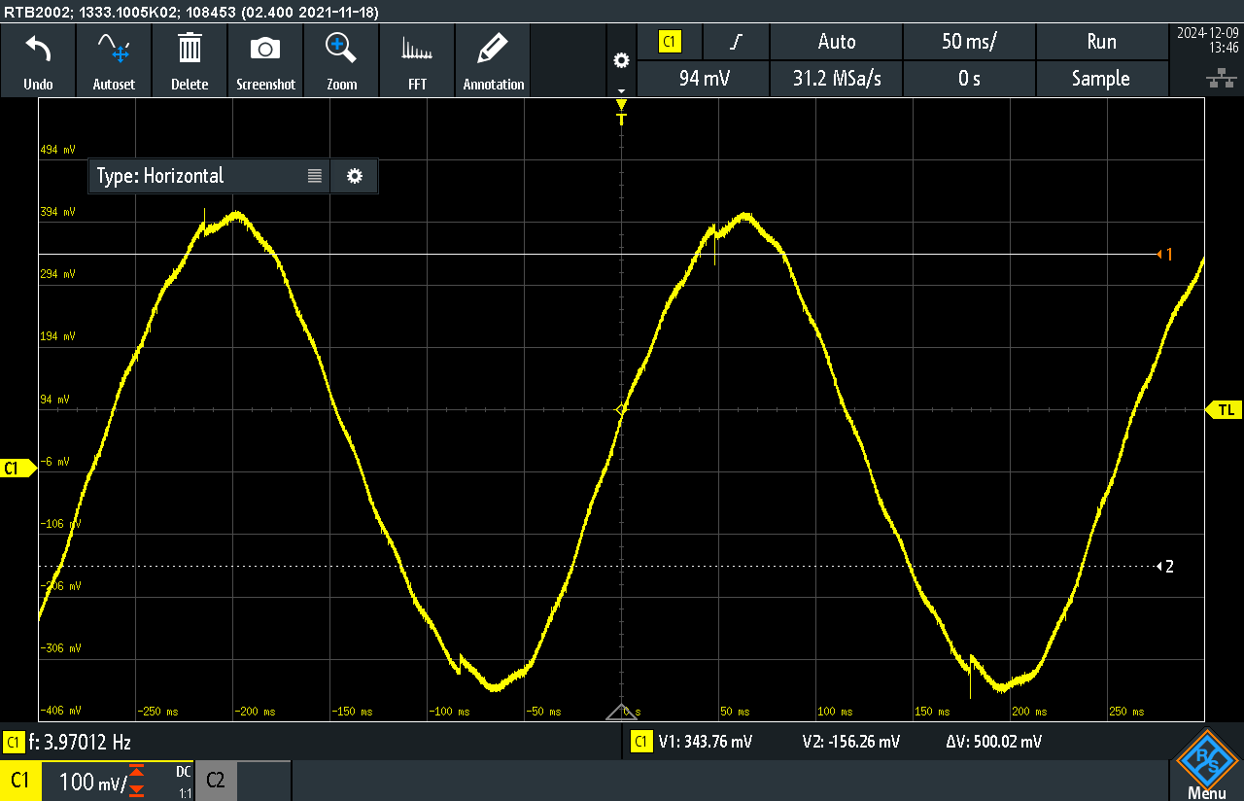

Figure 17 – IRM-AT Final Output Waveform

The final challenge for the integration of the IRM-AT was its calibration, to turn the analogue readings into a true CH4 concentration. This was difficult as, unlike with the PID-AH sensor where I was able to test it against VOCs, I was not given permission to experiment with CH4. Hence, indirect methods had to be used to find the offset and scale factor. The offset was the simpler of the two to find, as mentioned above the reference and detector output should be equal at ambient conditions; to confirm this, the sensor was left running for 2 hours in the clean air of the Ashby Electronics Laboratory from which a table of the two outputs across the test was recorded. From this table, it was found that the two were not typically equal, but that the detector value was, on average, less than the reference value by a value of 4, thus giving the required offset. Next, the IRM-AT’s datasheet **[20]** explains that a 5% drop in the detector output is typically found at 2.5% CH4, while a 30% drop is observed for 100% CH4. This non-linear scale made it difficult to properly deduce the scale factor to convert the output into a concentration; however, I decided that, because it is CH4 emissions that was to be monitored, rather than high-volume production, it would be more accurate to assume the lower bound. Thus, a scale factor of 0.5 was decided upon, which would be subject to change depending on the performance of the sensor during tests. **Equation 2** illustrates the formula of how the scale factor and offset are used to convert the analogue outputs into the CH4 concentration in %vol.

*Equation 2*

$$CH4 Conc. =\left(\left(\frac{Ref-\left(Detector+4\right)}{Ref}\right)*100\right)*0.5$$

## 5.6 Sensor Selection Themes

**Table 1** lays out the main specifications of each of the sensors above, from which clear themes in selection can be observed in alignment with the project goals. Firstly, the sensor price, discounting the anomalously expensive PID-AH, the mean price of the other sensors is only £52.62. As explained with the Aeroqual Series 500 in **Section 3**, expense is a major concern of farmers, a solution no matter how comprehensive is useless to them if it is too expensive to purchase, so selecting the highest quality sensors for the cheapest price was paramount. Carrying on with this theme of cost-effectiveness, sensor robustness and practicality were also important, as components with short lifespans only create a ‘money-pit’, where the farmer would have to regularly purchase new sensors. One outlier in this department is the pair of electrochemical sensors by DFRobot, who have limited lifespans by nature due to the depletion of their chemical reactant. To offset this though, those sensors also happen to be some of the cheaper components in the system. Furthermore, other sensors, like the two by Sensirion, then have life spans of over a decade. All the sensors are also capable of handling temperatures and humidities far beyond what would be expected on a UK farm, keeping the risk of damage due to environmental conditions to a minimum, so long as the device is not directly exposed to the elements. Sensing accuracy was another major concern, addressed by having high-resolution, higher-accuracy sensors then the competition, as focused on in each sensors’ sections. The final theme of note was the sensors’ current demands: sensors with low draws were intentionally selected for the practicality of being able to power the entire system with the Arduino Mega’s voltage supply lines alone. This greatly saved time as a separate PCB and circuit for distributing power did not have to be incorporated, simplifying the system and keeping costs lower.

Table 1 – Sensor Specifications

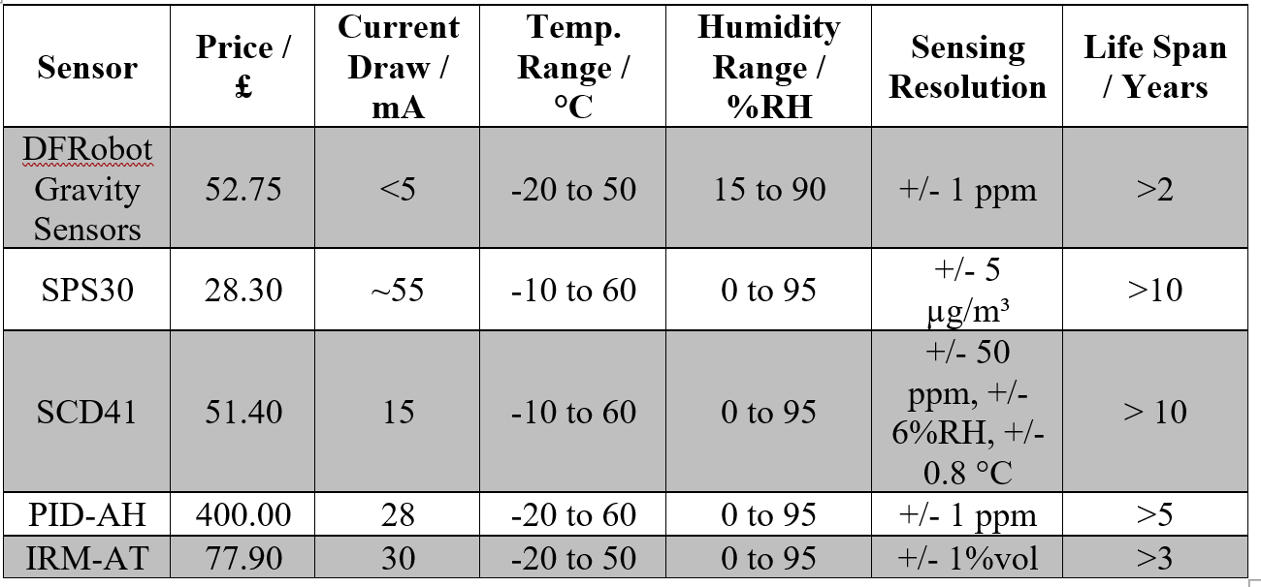

# Data Displaying & Recording

This section will go through the different components which form the data displaying/recording subsystem mentioned in **Section 4.2**. It will firstly explain the reason for the component’s inclusion before moving onto the integration process of testing the component individually and then as part of the full system. Challenges with implementation will also be explored for each sensor, with some proving to require more complex processes than others.

## 6.1 Youmile LCD Screens

As explained in **Section 4.1**, a physical display was deemed to be more appropriate to achieve this project’s goals over an IOT online dashboard; this left a choice between that of an Organic Light-Emitting Diode (**OLED**) screen or a Liquid Crystal Display (**LCD**) screen. Out of convenience, an OLED screen was ordered because it had the fastest delivery time, which made it possible to test the screen on the following day. The OLED screen ordered is as in **Appendix 10** and, upon initial testing, obvious shortcomings became apparent. Firstly, its size: the screen only measured 34 x 36 mm, making it difficult to read data. Next its operational code: there were only basic libraries available for it and displaying more complex symbols required the manipulation of individual pixels, which was impractical and time-consuming. Further research into weaknesses of OLED screens also revealed that they are prone to ‘burn-in’, explained by Pino **[21]** as when certain pixels in an OLED screen retain an outline of an image after the screen has been turned off. The most common source of burn-in is extended operation and, as the aim of the device is continuous monitoring, such an effect is clearly off-putting.

On the other hand, when delving deeper into LCD screens, I discovered that, although their picture quality may be lower, this sacrifice leads to it being more energy efficient as well as having a longer lifespan, especially for continuous use **[22]**. Furthermore, after looking at tutorial videos on their use on Youtube.com, I found that there were already built-in Arduino libraries which comprehensively controlled the display. Such advantages made it obvious that LCDs were the optimum choice over OLED, and so a pair of 20-04 LCDs by Youmile were ordered (**Figure 18**). These LCDs were chosen because they came with an I2C communication module pre-soldered, making integration much simpler.

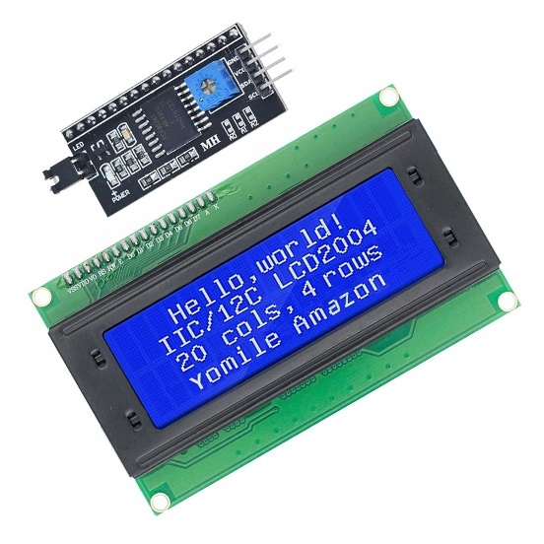

20-04 LCD

I2C Module

60 mm

98 mm

Figure 18 – Youmile LCD Screen [ref Appendix 11]

When integrating the PCBs, the only notable extra step required was to change the I2C address of one of the screens, done by simply short-circuiting a pair of pads. This was a necessary step as the software for I2C communication requires each peripheral to have a unique address so the microcontroller can differentiate between each one, different components normally have different addresses but in this case where there are two identical components, one had to be amended. Once completed, the four I2C connections were put in place and each LCD was tested with the software learned from tutorial videos. Finally, the LCDs were integrated into the main system, displaying the data as in **Figure 19**.

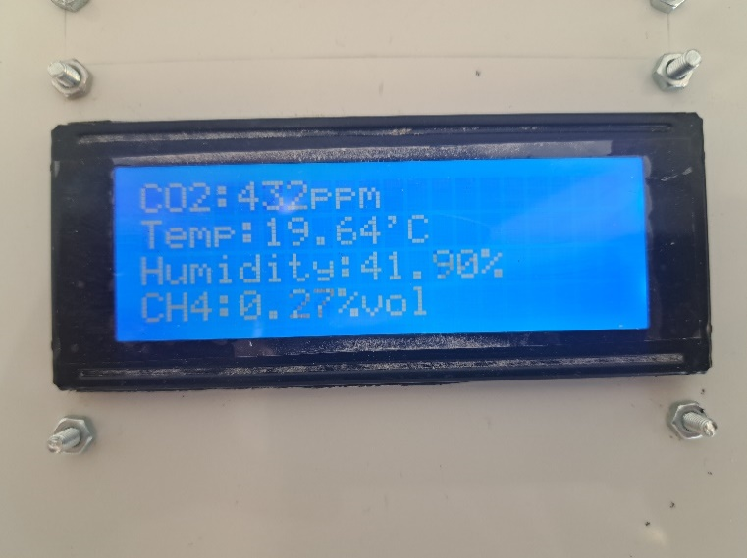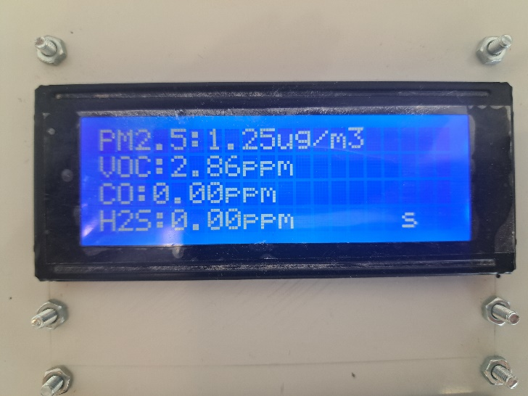

Figure 19 – LCDs Displaying Readings

## 6.2 kwnmobile Micro SD Card Module

As mentioned in **Section 4.2** the project device was given on-onboard storage rather than relying on the Arduino’s own internal memory, this was added in the form of a Mirco SD card module by kwnmobile, as seen in **Figure 20**. This component was selected because of its popularity and high recommendations from a multitude of tutorial videos on Youtube.com.

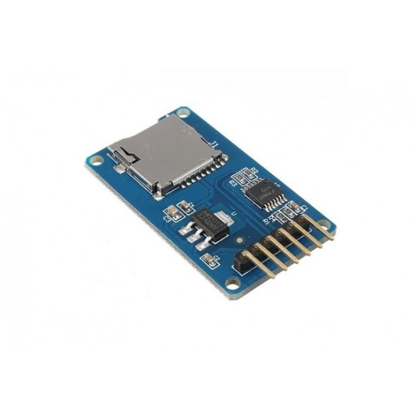

28 mm

45 mm

Figure 20 – kwnmobile Micro SD Card Module

A notable point about this component is that, while it communicates digitally to the Arduino, it does so via the SPI communication protocol which requires six connections rather than I2C’s four. However, as this was the only peripheral which utilised SPI, the extra connections were kept to a minimal and the module was placed as close to the Arduino’s SPI pins to minimise traffic. Thus, with the wiring arranged and code learnt from tutorials ready, the module was then primed to be tested with a 64 GB Micro SD card.

A major problem faced in this initial testing stage was a software issue in that, even though the Micro SD card was plugged in, an error claiming there was no card kept occurring. The first assumption was incorrectly typed code, but after combing through, line by line, and comparing it to multiple tutorials, no issue was found. The next avenue investigated was a faulty module, so it was replaced with another, as multiple modules were ordered as a contingency, but the error still persisted. It was only after watching a tutorial by Robojax **[23]**, where the issue was correctly diagnosed. In the video, he explains that the Micro SD card must specifically be in the FAT32 file format, otherwise the module and hence the Arduino would not recognise its connection. This posed a second problem in that the FAT32 format was only available of Micro SD cards which had a capacity of 32 GB or below, meaning the one procured was unusable. After acquiring a 32 GB Micro SD card, the module worked with no issues.

With the on-board storage operational the readings could begin to be saved but this posed a new problem in that, while the readings could be saved there was no way to save the times when they occurred, making the data nearly meaningless as the user will have no idea what actions lead to such emissions. This exposed the need for a real-time-clock (**RTC**) module which could accurately keep track of the time, even when the device was powered off, further explained in the following subsection. With that issue addressed the data saving feature could be tested. The first attempt was to simply save the data into a .txt file as it was the simplest method. While this was effective, it made data analysis extremely difficult as patterns could not be analysed with computer-aided tools. This led to the decision to save the data onto a .csv file in the format as shown below in **Table 2**. This format made it simple to analyse the data as the files could be opened in any spreadsheet software, like Microsoft Excel, and then the data could be graphed to for analysis.

Table 2 – Example File Saving Format

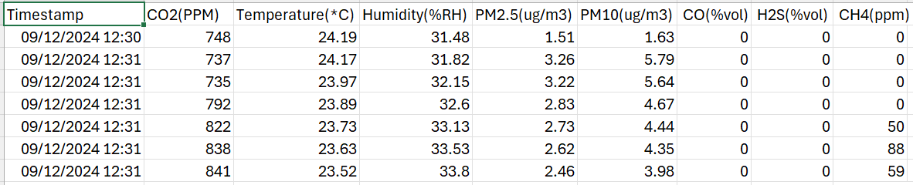

The final problem discovered with file saving was the size of the files: the initial method being to create a single file at the moment the device is switched on and then saving all subsequent measurements onto that file. While this was fine for testing, as the device would only be on for several hours at most, it would be unfeasible for the continuous monitoring planned as it would produce an impractically large file, which would inhibit data analysis. Hence, to solve this issue I created custom code, exhibited in **Appendix 12**, in which a new file would be created at the beginning of each day, making data analysis much more manageable.

## 6.3 DFRobot RTC Module

As mentioned above the data saving system hinged on having an accurate RTC to keep track of the times the readings occur, so that the farm would be able to make sense of the data and hence, react to it accordingly. For this role, the DFRobot DFR0151 RTC (**Figure 22**) was selected as it conveniently could communicate to the Arduino via the I2C protocol.

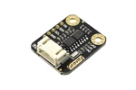

27 mm

22 mm

Figure 21 - DFRobot DFR0151 RTC Module [Ref Appendix 13]

The integration of the RTC, thanks to its simple connections and comprehensive tutorials online, was straightforward and the device was able to keep the time immediately. A minor hiccup was experienced when a 3.3 V coin cell battery was placed into the RTC, to allow it to keep the time even when the system was off, in that the system became unable to recognise the RTC’s connection. However, after deconstructing and reconstructing the code component, by component the issue was resolved.

# Alarm Monitoring

## 7.1 Pollutant Thresholds

When determining pollutant thresholds, two tiers were of degrees were planned: firstly, a level 1 alarm in which the pollutant has reached a concerning level, and that the farmer should investigate the cause before it gets worse. Next, a level 2 alarm, where the pollutant has reached a dangerous and potentially lethal concentration, where people and animals nearby should be moved away from the area, and a thorough investigation into the cause while wearing appropriate protective equipment should be performed. **Table 3** displays the alarm thresholds for each pollutant, set from research papers and articles. Each threshold is also associated with a time limit where the alarm must be past the threshold for that period before the alarm sounds, to prevent against false positives. Level 1 limits are breached after 1 hour, or 30 minutes for the more dangerous CO and H2S, and all level 2 thresholds have a time limit of 10 minutes.

Table 3 – Pollutant Exposure Limits

|  |  |  |
| --- | --- | --- |
| **Pollutant** | **Level 1 Limit** | **Level 2 Limit** |
| CO2 **[24]** | 1000 ppm | 5000 ppm |
| PM2.5 **[25]** | 15 μg/m3 | 25 μg/m3 |
| PM10 **[25]** | 45 μg/m3 | 75 μg/m3 |
| CO **[26]** | 10 ppm | 200 ppm |
| H2S **[27]** | 20 ppm | 100 ppm |
| CH4 **[28]** | 1%vol | 5%vol |

## 7.2 Alarm Operation

**Figure 23** displays the components which make up the hardware of the alarm subsystem. If a level 1 alarm is triggered, the red LED will begin to flash, and a warning symbol denoted as ‘(!!!)’ will be displayed beside the pollutant(s) which triggered the alarm on the LCD screens. At this stage though, the device will still operate as standard: measuring, displaying, and recording readings as before. This operation was selected for a level 1 alarm as it will draw attention without inciting panic; this is because, as mentioned above, level 1 alarms are a cautionary measure, to warn the farmer to react before conditions become truly dangerous. For a level 2 alarm however, the aim is indeed to invoke an immediate response from the user as conditions have become potentially lethal and rapid action is needed. Hence, to demand the users’ attention, the buzzer will begin to sound off and the LCDs themselves will begin to flash and only the triggering pollutants will be displayed on the screens. The buzzer in particular will be useful, especially if animals are present, as it will elicit a stronger response from them. Finally, the occurrence of an alarm, of either level, will also be recorded onto the .csv file beside each recorded reading of the triggering pollutant with “(concerning)” for a level 1 alarm and “(dangerous)” for a level 2 alarm. This will aid in the farmer in reviewing the data to see at what time, and hence, because of what activity caused the alarm.

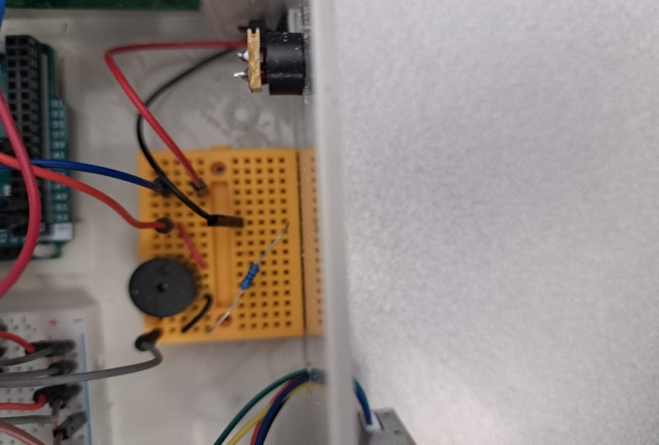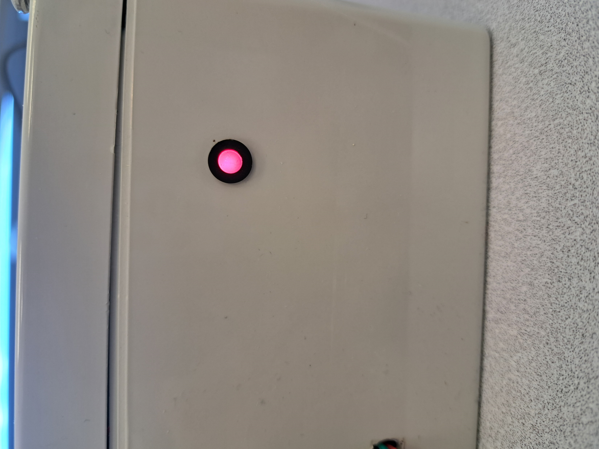

Alarm Buzzer

Alarm LED

Figure 22 – Alarm System Hardware

## 7.3 Alarm Subroutine

The implementation of the alarm system was heavily software based, where I made custom subroutines to continuously compare the pollutant concentrations against the set threshold values while simultaneously keeping track of how long the concentrations were elevated. This was achieved by firstly setting variables for threshold values and time limits, these were set as local variables in the main operation loop to save memory space on the Arduino. On the other hand, global variables were set for the alarm statuses and counters to keep track of elapsed time. The latter needed to be global variables because a local variable is only in use during the subroutine’s operation and is reset each cycle, by being set to global, any updates to the variables are kept. The flowchart in **Figure 23** illustrates the steps the code followed in the alarm status check subroutine: beginning first, at evaluating which threshold the pollutant has reached, then checking if it has been at that threshold for longer than the maximum exposure limit, and if both are found to be true then the appropriate alarm is set.

Pollutant Concentration Measured

> Lvl 2 Threshold?

Lvl 2 Alarm Activate

Lvl 1 Alarm Activate

Counter 1 > Lvl 1 time limit?

Counter 2 > Lvl 2 time limit?

Pollutant Lvl 2 Counter ++

Lvl 1 Counter = 0

> Lvl 1 Threshold?

Pollutant Lvl 1 Counter ++

No

No

No

No

Yes

Yes

Yes

Yes

Figure 23 – Alarm Subsystem Flowchart

The final feature of the alarm system was that the alarm would only turn off if the user manually reset the device by pressing the reset button built into the Arduino. This ensured that the alarm had to be acknowledged by someone, which ideally has a knock-effect of the farmer looking through the saved data, learning which activity caused the alarm, putting in place measures to prevent it repeating, thus increasing the general standard of air quality on the farm.

# Completed System Overview

This section will go through the integration of each element from the previous three sections into the complete air quality monitoring system. Beginning with explaining the complexities of the final wiring schematic, moving onto the process of housing system into a portable and robust enclosure, and finally a brief analysis of its cumulative specifications.

## 8.1 Wiring Connections

To aid in keeping track of connections, a system wiring diagram (**Figure 24**) was made on Draw.io and was updated with each component added. It was particularly useful in the process of transferring the system from a bare-board state into its enclosure, explained in **Section 8.2**. From the diagram, one can see how selecting a majority of components which could communicate digitally to the Arduino via I2C greatly simplified the connections, as the same four lines (Vin, ground, SDA, and SCL) went to eight of the eleven peripherals. Seeing this visual representation of the connections also aided in the practical implementation of the system, such as how the Micro SD card module needed more connections than others but they were all unique to itself so by placing it on its own in a space close to the Arduino, the connections could be managed in a much neater way.

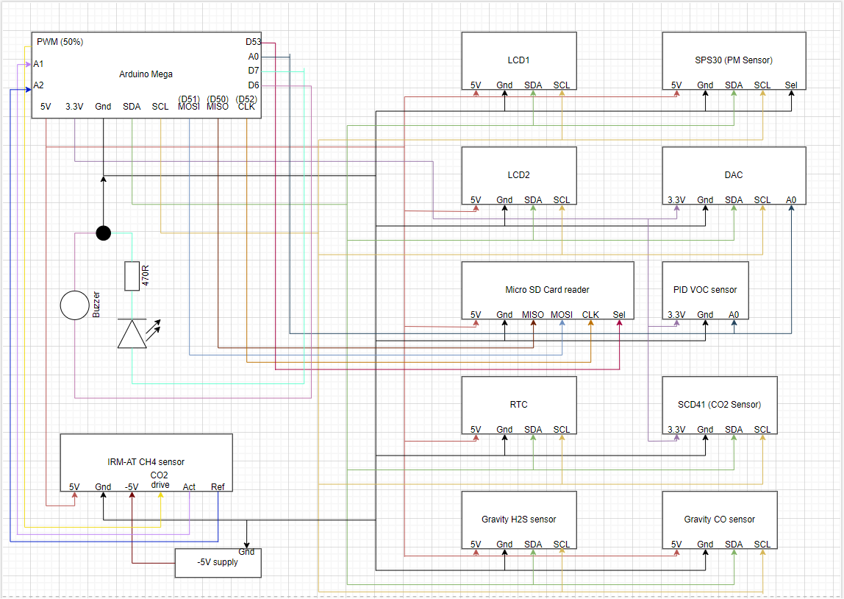

Figure 24 – Final System Wiring Schedule

**Figure 25** then displays how the wiring diagram looks in practice, with a breadboard serving as the central hub connecting all the components to shared lines from the Arduino. The breadboard was convenient for the I2C lines by having a pair of rails which went all the way from the top to the bottom, these rails were used as the I2C rails with the left being 5 V and ground and the right being SDA and SCL. This allowed for all the I2C devices to be easily connected in parallel across the entire length of the enclosure.

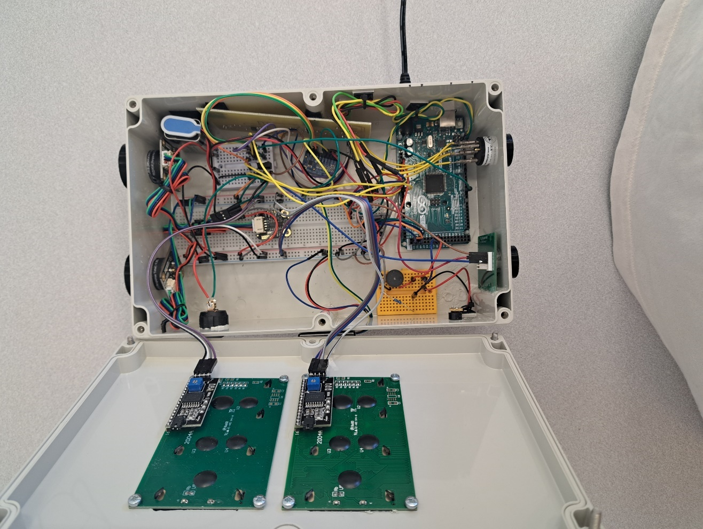

Figure 25 – Wiring Connections in Practice

## 8.2 Enclosing the System

The system was to be housed into a 250 x 160 x 90 mm enclosure made of Acrylonitrile Butadiene Styrene (ABS), a polymer noted for its strength, durability, and lightweight. This enclosure was chosen mainly for its ideal size: being large enough to contain all the components comfortably while also being small enough to be easily portable. A polymer enclosure was chosen over a more durable metal one because modifications to the enclosure, in the form of holes being drilled in its body were required. This is because the sensing surface of the sensors needed to be exposed to the air, so precisely drilled holes were created by the EEECS technicians in the Ashby 9th floor laboratories to allow the sensors to protrude from inside the enclosure. To aid in the protection of the sensors, I designed and 3D printed shrouds which covered the sides of the sensor while leaving the sensing surface unobstructed, as shown in **Figure 26**. The completed, enclosed system is displayed in **Figure 27**.

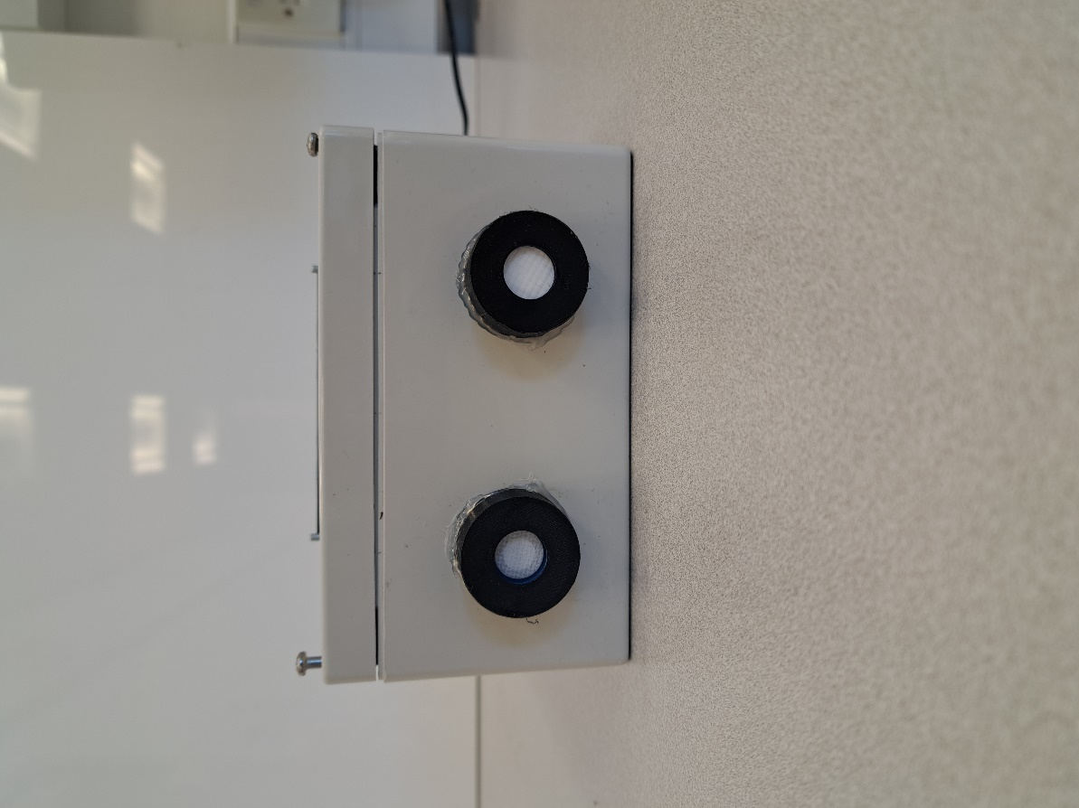

Shroud

Sensing Surface

Figure 26 – 3D Printed Sensor Shrouds

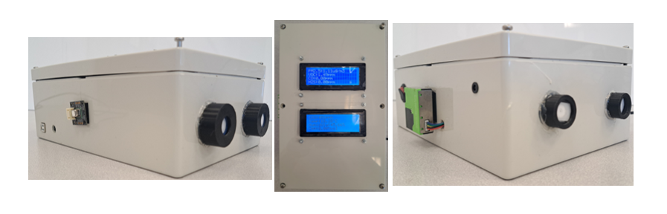

Gravity CO

IRM-AT

PID-AH

SPS30

DC Jack

Gravity H2S

SCD41

Alarm LED

LCDs

Figure 27 – Completed Project Device

## 8.3 Device Specifications

With the project device complete, its overall specifications could be analysed in order to compare it to the current models, to confirm that it has, at least in theory, achieved the project goals and surpassed the present state-of-the-art in functionality and cost-effectiveness. **Table 4** summarises the findings of this investigation. The most glaring parameter on the table is the solution’s overall price, totalling to £742.55, significantly more than the cheaper devices currently on sale, like the previously mentioned Temtop M2000 at £142. However, as explained in **Section 5**, this increase in price is necessary to afford not only a larger number of sensors but also higher-quality sensors for more accurate measurements. As such, the increase in price is acceptable, especially when considering that competitors of comparable standard with regards to comprehensive air quality monitoring, like the Aeroqual Series 500, will cost double the device at over £1400 at least.

A significant boast of the project on the other hand is its current draw: the project device only draws a peak of 350 mA at the point of measurement, 65% less than inferior Temtop, displaying the efficiency of the device. This parameter was found practically via an ammeter to measure the current draws at the Arduino’s 5 V and 3.3 V supply pins, as well as the overall current draw from the DC Jack. From the 5 V supply, a base draw of 165 mA which rose to 180 mA at measurement was measured, and for the 3.3 V supply it was 27 mA rising to 76 mA. The much larger increase for the 3.3 V supply can be attributed to the PID-AH, which requires more power for its UV lamp. Overall though, these values are much lower than the expected 464.5 mA draw, calculated by totalling the values of the components’ typical current draws from their data sheets. The total ambient draw of 290 mA minus the ambient draws of the two supply pins then gives the Arduino’s current draw of 98 mA, which remains constant at all times.

This benefit is even more important when considering that the device is designed for continuous operation by being plugged into mains, hence, its efficiency will be cost-effective in the long-term. Finally, the practicality of the device, in summary of points made in previous sections, the device, though bulkier than the competition, remains easily portable and is more than capable of handling typical environmental conditions, provided it is not directly exposed to the elements. Its operational lifespan is determined by the sensors’ lifespans, however the sensors are easily replaceable.

Table 4 – Completed Device Specifications

|  |  |
| --- | --- |
| Dimensions | 250 mm x 160 mm x 90 mm |
| Power Supply | 9 V, 2 A DC Supply (centre +ve) |
| Current Draw | 290 mA (idle), 350 mA (measurement) |
| Intended Use | Indoor |
| Minimum Lifespan | > 2 years |
| Temperature Range | -10 °C to 50 °C |
| Humidity Range | 15%RH to 90%RH |
| Total Price | £742.55 |

# Test Procedures and Outcomes

This section will break down the practical tests performed on the final device, going through the test procedures and scrutinizing its performance via the recorded readings and comments made by volunteers who tested the device.

## 9.1 Home PM Test

The first test performed on the device upon its completion was a simple functionality exam to confirm that the system worked as designed. The setup, as shown in **Figure 28**, was for the device to be stationed in a kitchen where actions like cooking would be performed to artificially raise the PM concentration in the room. In this, the pollutant sensing and data diaplaying/saving subsystems would be heavily utilised during the test with the potential of the alarm subsystem being activated as well.

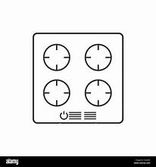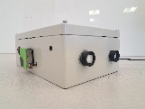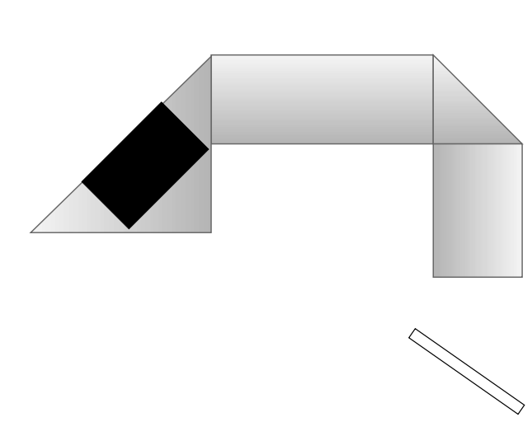

1 m

2.5 m

Exit Door

Device

Toaster

Hob

Figure 28 – PM Home Test Setup

The resulting plot for PM2.5 and PM10 is displayed in **Figure 29**. The test to examine the device’s ability to plot PM commenced at 20:30 and concluded at 21:10, however the device was left running until 22:10 to make sure that there was no drift in the measurements with extended use. The exact time each action was made in the experiment was noted down, in order to be able to correlate the readings to them and to check if there was any lag in the device’s measurements. The annotations in **Figure 29** convey the times of significant actions which artificially changed the PM levels in the room, and one can see the device’s readings changed almost instantly at each action. The most obvious being the PM spike at 20:38 because of the completion of the sausages being cooked and the immediate drop in readings right afterwards at 20:40 because the door was opened to let in fresh air. In this test all three subsystems were found to be working optimally as at 20:47 a level 2 alarm was activated because of prolonged high PM concentrations, the alarm was also reset exactly as designed and afterwards the door was kept open to prevent a second alarm, which is why the second peak was diminished. After the PM test, I observed the device readings in clean air for a further hour and confirmed there was no measurement drift for extended operation. Overall, this first test was immensely positive, confirming that all the systems functioned as intended and that the device readings displayed fast and accurate responses, as well as being stable over extended use.

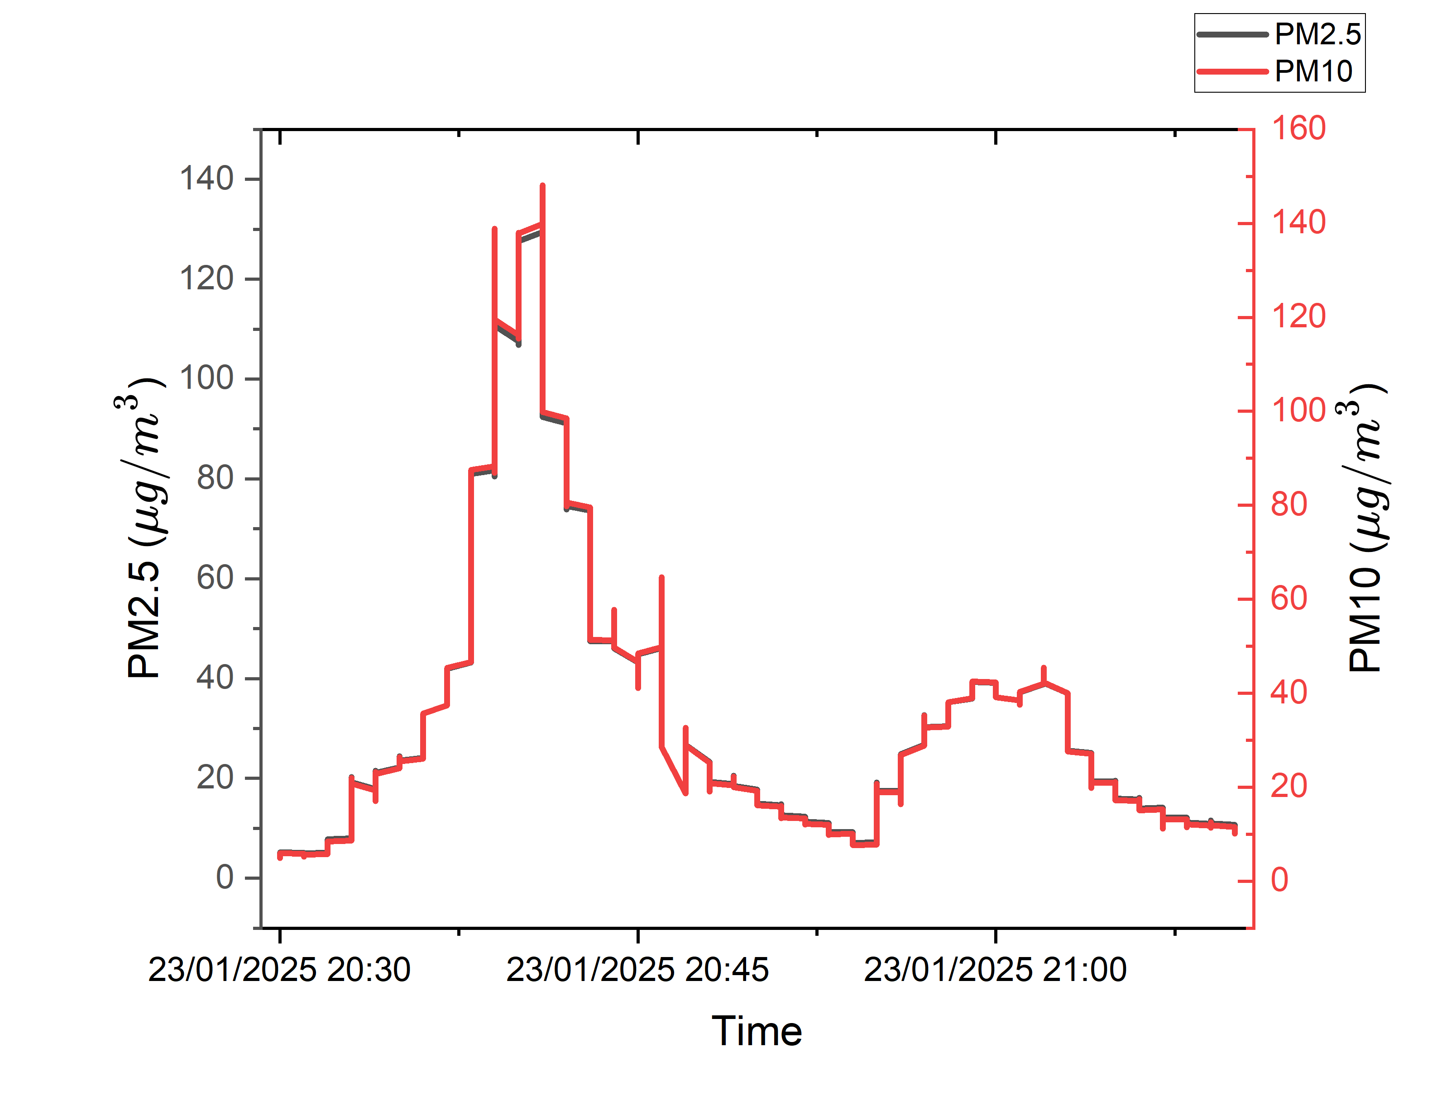

Hob On 20:30

Cooking 20:33

Hob Done 20:38

Door Opened 20:40

Toaster On 20:44

Device Reset 20:47

Toaster On 20:53

Figure 29 – Kitchen PM Test Results

## 9.2 Gas Boiler test

Initially, the plan was to test the CH4 sensor in the field tests explained in the following two sections, however, because of design flaws that will be elaborated on in further sections, no usable CH4 readings were recorded so a separate test to confirm the functionality of the IRM-AT was required. This was challenging because, as mentioned in **Section 5.5**, I was not given permission to directly experiment with CH4 and so had to find an indirect source. The first avenue attempted was to produce CH4 from the anaerobic decomposition of compost. For this experiment, food scraps, water, and pre-made compost were placed in a sealed plastic container and left to decompose beside the radiator for 1 week to encourage CH4 production. After the week, the container was opened inside a 22 l plastic bag beside the device (**Figure 30**), with the hopes of a rise in CH4 readings. However, no such rise was observed and another experiment had to be planned.

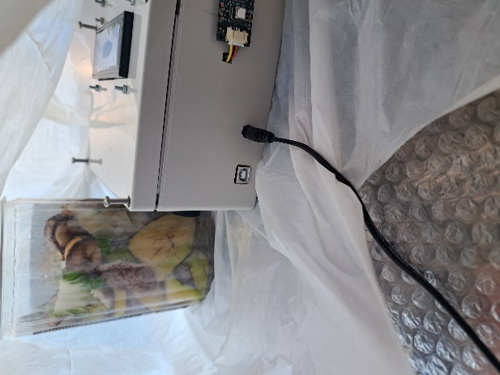

Figure 30 – Failed CH4 Compost Test

The Next experiment performed was to leave the device beside a natural gas boiler over an extended period of time. The aim being to compare the results of the experiment with the CH4 readings when the device is in clean air, the assumption being that the ambient value in the experiment should be above the ambient value in clean air because a minute amount of natural gas escaping from the pipes in a boiler is natural. The results of this investigation are displayed in **Figure 31** with **(a)** being the readings from beside the boiler and **(b)** being the readings in the clean air of the Ashby Building Electronics Laboratory. One can see in both cases there is a large amount of fluctuation in the readings, however, when a moving average (taken every 100 points) is plotted it is found that for **(a)** the ambient CH4 concentration is roughly 0.5%vol while for **(b)** the ambient -0.2%vol. Such results prove the initial hypothesis and provide evidence that the IRM-AT is indeed functional, however, its calibration requires much tuning, which would only be possible if tested against known concentrations of CH4.

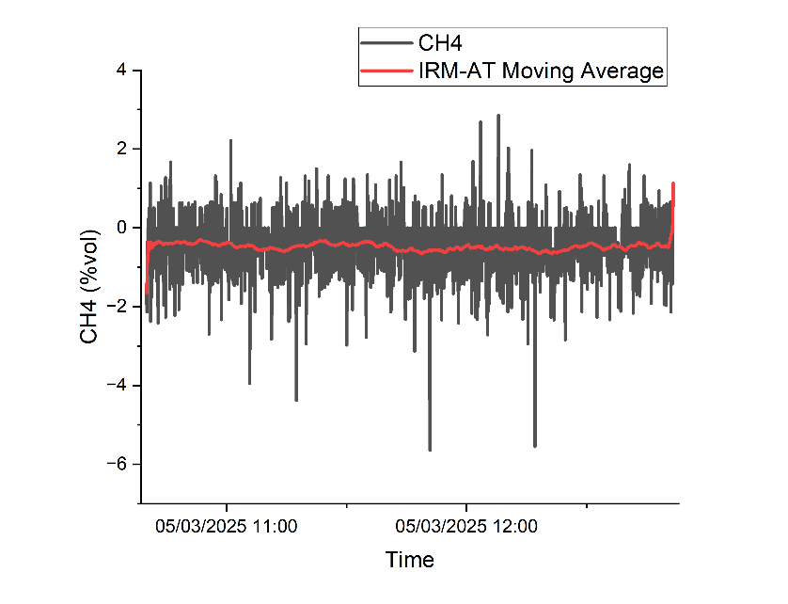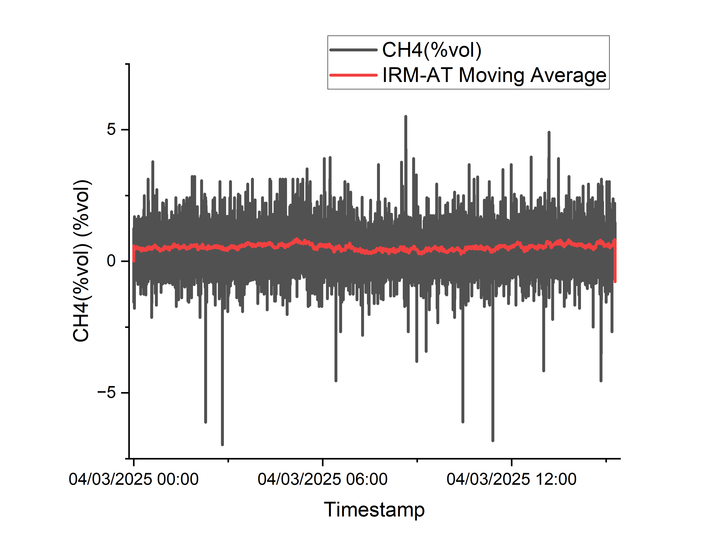

(b)

(a)

Figure 31 – Gas Boiler Test Results – (a) Device Beside Gas Boiler, (b) Device in Clean Air

## 9.3 Farm Test #1 (01 – 03/02/2025)

To get a true sense of the practicality and usability of the device, university connections were utilised to find a farmer willing to put the device into practice. It was fortunate that the volunteer was a dairy farmer from Omagh who presented the ideal test environment for the project: a cattle barn with an underfloor slurry tank. The plan was to send the device over from the 31st of January to the 3rd of February, and for it to continuously monitor the air quality inside the cattle barn over the weekend, especially focussing on H2S from their scheduled slurry mixing on the 1st of February. For this first test, the device was set up as in **Figure 32**, with the it set up on a 3 m ledge overhanging the cattle beds.

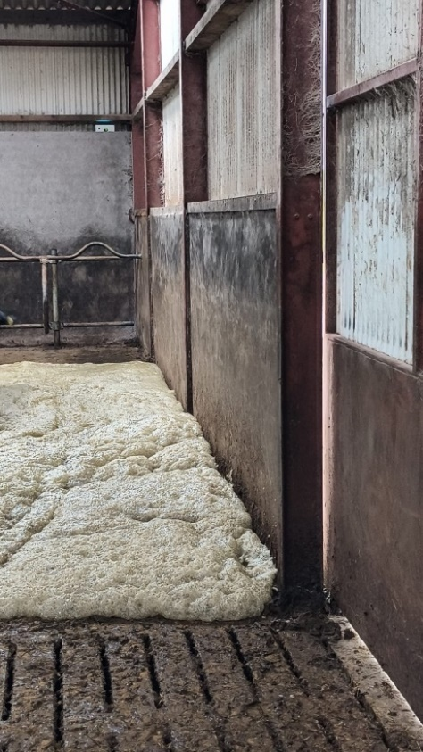

Device

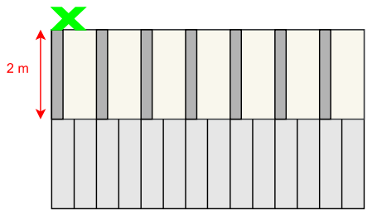

3 m

*Slurry Foaming up from Vents

Slurry Vents

Cattle Bed

Figure 32 – Farm Test #1 Setup

The farmer reported that the slurry mixing took place at 15:45, however, when analysing the H2S readings at that time, the H2S concntration only rose to 1 ppm from the ambient 0 ppm and the peak lasted less than 15 minutes. As the device has an error of +/-1 ppm, there is a possibility that these could even be faulty readings, but because the readings were 0 ppm for the entire test apart from the time of mixing, the change was almost certainly caused by the slurry fumes. The reasons why the reading was so low will be explained in dept in the following section.

While the H2S concentrations were unexpectedly low, the PM10 concentrations were unexpectedly high. **Figure 33** displays two massive peaks of PM10 at 07:40 and 18:30, it should also be noted that it was only PM10 which peaked, PM2.5 remained at ambient levels all throughout the experiment. This was peculiar as in previous experiments, especially the PM kitchen experiment in **Section 9.1**, the two parameters had always followed near identical trends. When questioning the farmer as to the possible cause of these peaks, he reported that those were the exact times that he would use the electronic cattle maid (**Figure 34**); a robot with rotating brushes that would go across the cattle beds sweeping waste off the beds and onto the floor then down into the slurry tank. After looking at videos of a cattle maid’s operation (**Appendix 14**), clear dust clouds are made by the brushes, and the results indicate that the dust clouds must reach at least 3 m in height, and likely higher given the significant peaks, to reach the device. The peaks also triggered a level 2 alarm and when one zooms into the peaks, as in **Figure 33**, this occurrence is unsurprising. Both PM10 peaks remain over the level 2 threshold (red) for over 15 minutes, and it takes over 30 minutes before concentrations fall back down to safe levels. Such statistics are extremely concerning as, especially in the winter, cows will spend nearly all day in the cattle barn, exposed to such high levels of PM10 regularly. Thus, I was able to offer advice to the farmer on improving cleaning practices in his cattle barn, such as waiting that minimum of 30 minutes before allowing his cows back because, as explained in **Section 2.1**, long-term exposure to PM can cause respiratory diseases in the cattle, which could become extremely costly.

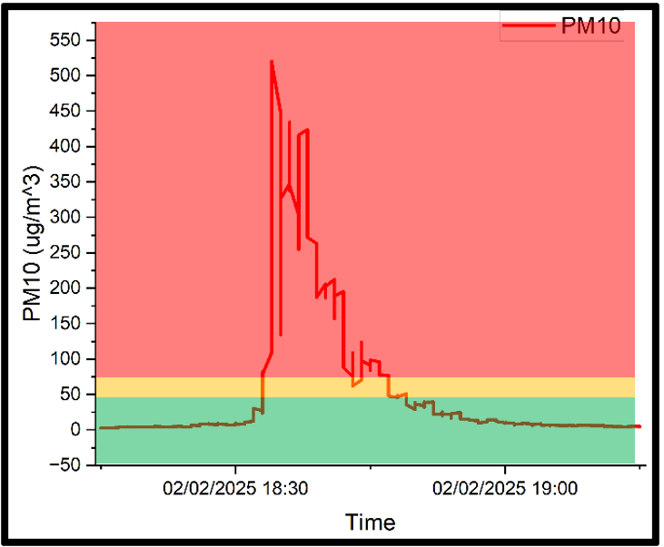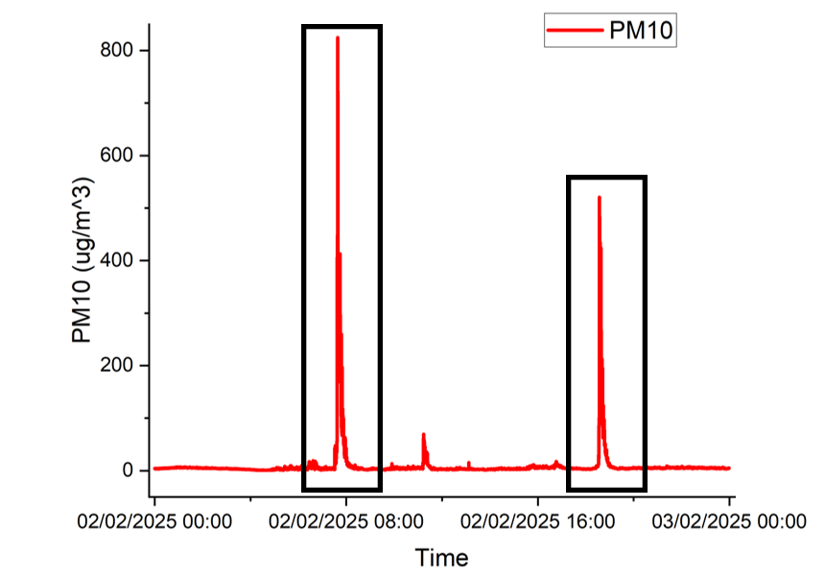

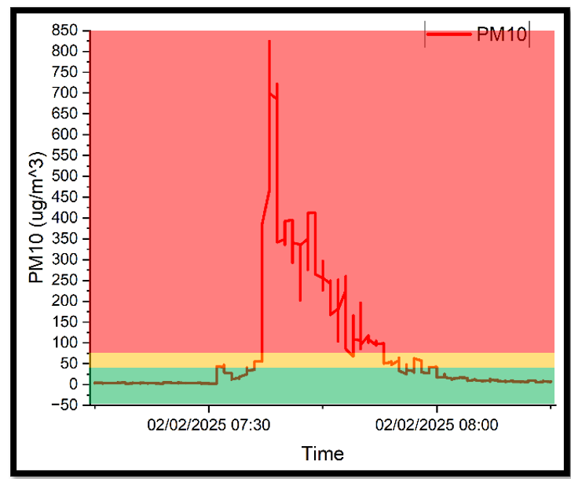

Figure 33 – Farm Test #1 PM10 Results

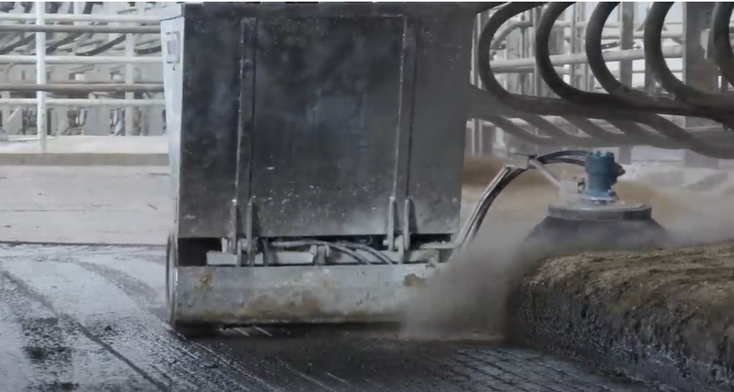

Figure 34 – Electronic Cattle Maid (PM Cloud Circled) [red Appendix 4]

To summarise the findings from Farm Test #1, the device shows much promise in achieving the project goals as in its first real-world test, it has already provided vital information which was able to advise the farmer on the air quality of his barn, he himself was surprised at the PM levels shown. The device has also proved it is capable of continuous operation, running non-stop for 3 days, and when the data for each parameter was analysed, no measurement drift was found and instead, consistent patterns verified the measurements’ reliability. Much room for improvement was also discovered regarding the device’s operation and user-interface, explained further in **Section 10**.

## 9.4 Farm Test #2 (08 – 12/02/2025)

The lessons learned from the first farm test were implemented for Farm Test #2, in order to achieve better device functionality in the form of improved results. The primary lesson was device placement, in the investigation to explain why the H2S concentration was so much lower than expected, I learnt that H2S molecules are heavier than ambient air, meaning that it collects in low areas **[29]**. This explains why, being 3 m up on a ledge, the device recorded only 1 ppm of H2S. Hence for this second test, the device was placed as low as possible on one of the cattle beds, directly beside the slurry vents as shown in **Figure 35**.

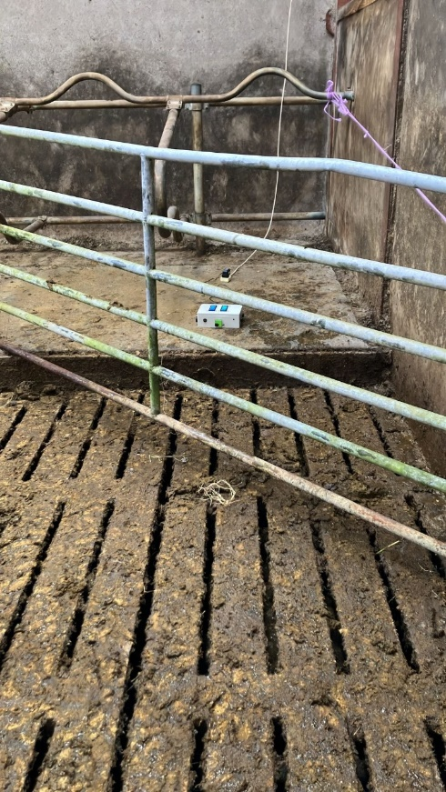

Device

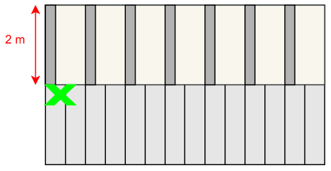

Cattle Beds

Slurry Vents

Figure 35 – Farm Test #2 Setup

Following this amendment the readings for the slurry fumes in Farm Test #2 are much more promising than the previous farm test, as illustrated in **Figure 36**. The farmer reported that slurry mixing commenced at around 15:30, and as shown in the plot, a massive peak of H2S, VOCs, and unexpectedly CO2 was observed at that exact time. An interesting point of note is, when zoomed into the main peak, a smaller but still significant peak several minutes prior to mixing is also observed. When speaking to the farmer about this observation he explained that when slurry is left for several days a hard crust forms on its surface, and just before mixing, when the slurry agitator is first put into the tank, that crust is broken up. From this I concluded that the initial peak is likely already built-up gas in the slurry escaping, with the crust opening up. These findings are overall very concerning however, as the three pollutants recorded all greatly surpass their level 2 thresholds for the duration of the slurry mixing, meaning conditions in the barn are potentially lethal for around 45 minutes. Furthermore, both H2S and VOC sensors hit their sensing maximums, indicating that the true values are likely to be much higher, and hence, the fumes are even more dangerous than recorded. The farmer was again surprised by the magnitude of these readings but was thankful for the advice I was able to pass on to him.

A final interesting observation in the slurry fumes was that the CO2 peak lagged the other two pollutants by several minutes, this is most obvious in the magnified image of the peak. Several theories stem from this which could be interesting avenues for future investigations, such as if CO2 is made in a latter reaction, or if there is perhaps a lag with the sensor itself. A sensor lag though is unlikely given that other tests on the SCD41 have seen it respond to changes in CO2 in a matter of seconds however, it has never been tested at such high concentrations as over 10,000 ppm, which may affect its performance. Another theory, suggested by a friend whose family works in farming is that, although some CO2 is indeed released by the slurry fumes, the majority of the total emissions measured may be from the tractor’s engine. This is because often it is the farmer’s tractor that drives the agitator which mixes the slurry, and to do so the tractor’s engine would be operated at maximum revolutions-per-second for the duration of the mixing. This theory also explains why concentration of CO2 in the initial peak of escaping gasses is so much lower than the main peak, because at that stage the tractor would not have been operating. This observation displays how the device meets its goal in GHG monitoring, as in this case, it directly shows to the farmer their GHG emissions during a common activity, and with this data they will be able to act more responsibly to lower emissions, such as by perhaps decreasing time spent mixing.

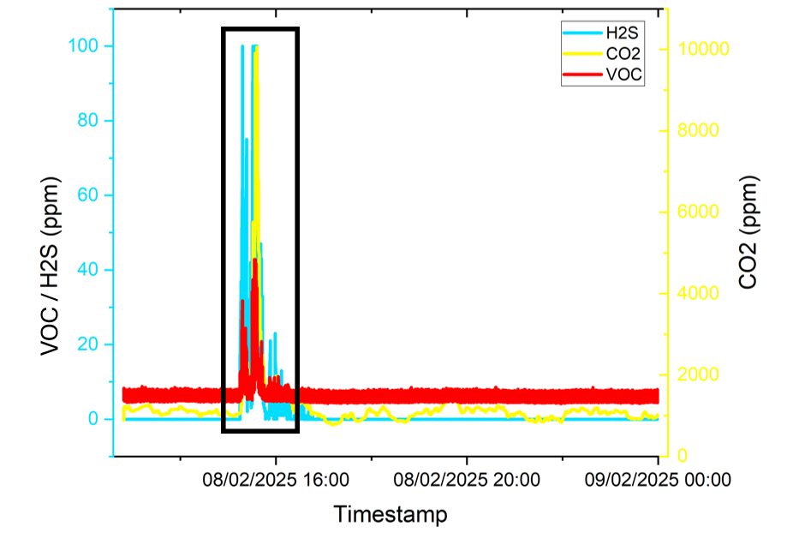

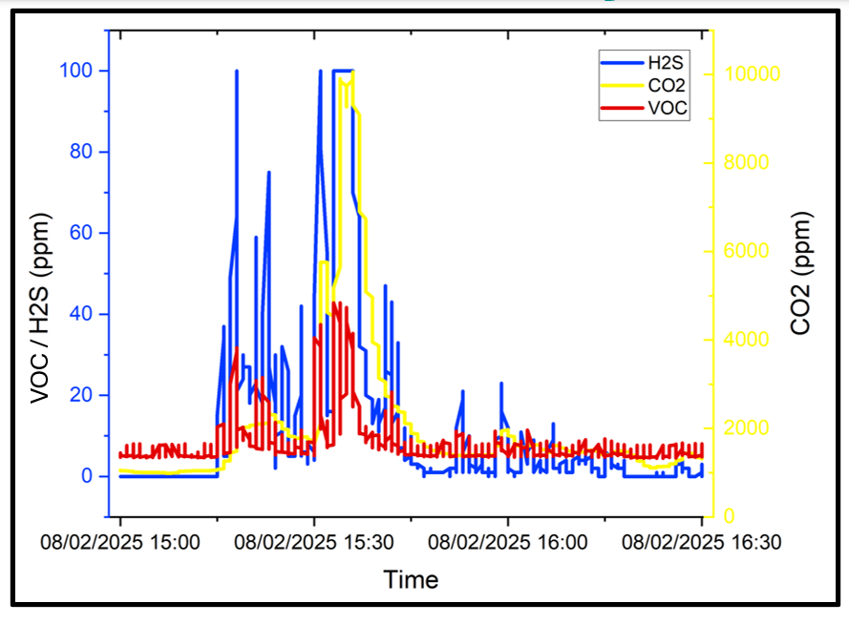

Figure 36 – Farm Test #2 Slurry Fume Readings

# Project Timeline and Progress

## 5.1 System Design & Integration (Pre-Interim Report)

With the vision of the system’s operation in mind, the design and implementation to realise that vision could commence. **Figure 7** models the engineering process utilised to form the final device component by component.

Identify challenge to solve

Find Appropriate Component

Test Component Individually

Integrate to Main System

Figure 37 – Design and Implementation Process

The first step of identifying the challenge to solve would be decided on during weekly meetings with the project supervisor where, after reviewing the current progress made, we would decide on the logical progression of the device in its journey to the final vision. Once the challenge was selected, I would then search through supplier websites, such as RS Components, to find the most suitable component to fulfil the task required and once found I would then order it through the EEECS technicians on the Ashby Building 9th Floor Laboratories. While waiting for the component, preparation would be done by reading its datasheets and watching tutorial videos on Youtube.com so that, when received, the component could be immediately tested in its own circuit with an Arduino Uno microcontroller. Once confirmed that the component was functional, it would then be added to the main circuit controlled by the Arduino Mega, and its operation code would be added to the main system code, titled ‘full_integration.’

This design and integration stage took the longest period to complete, due to the sheer number of components which had to be tested and then integrated. As one can see on the Gantt charts in **Figure 8**, it took the whole of the first semester to completely integrate all sensors and other peripheral components into a single, working system all housed into an enclosure. The Gantt charts also display how tasks were undertaken in parallel to maximise efficiency, this was done thanks to the 2 – 3 days wait time for the components to arrive after being ordered. This method allowed for consistent progress with the project evolving each week as a new layer of complexity was added. In this capacity, each week had a notable milestone, as a new component added meant that the project stepped closer to its final vision. Setbacks are also clearly visible on the Gantt charts, most obvious with the integration of the CH4 sensor in **Figure 8(b)** encompassing 5 weeks on its own. Such setbacks will be expounded upon in **Sections 6 & 7** as the challenges with integrating each component is explored in-dept. These challenges did however, lead to the most growth in both technical and practical skills as they taught me new and innovative ways to utilise the basic theory taught in class to problem solve.

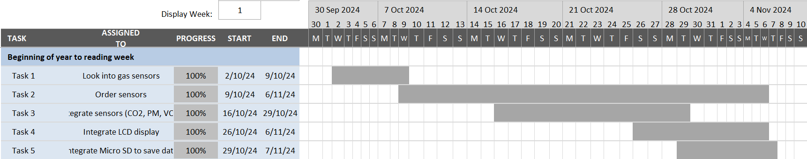

(a)

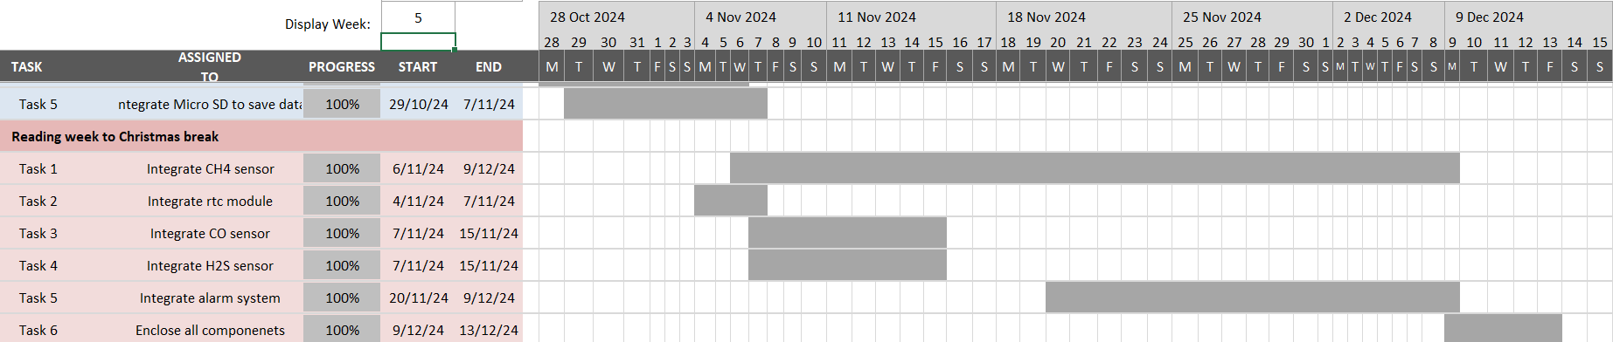

(b)

Figure 38 – Gantt Chart for Design and Implementation Stage – (a) Semester 1 First Half, (b) Semester 1 Second Half

## 5.2 Reflection on Progress (Post-Interim Report)

With the System design and integration complete at the end of the first semester, the focus at the beginning of the second semester was to document the work completed and to explain the design decisions made via the interim report. This final dissertation will go into further detail into each of the topics mentioned in the interim report, which was limited due to document size constraints. This report will also go through milestones reached after the interim report, as illustrated by the Gantt chart of completed work after the interim’s submission in **Figure 9**.

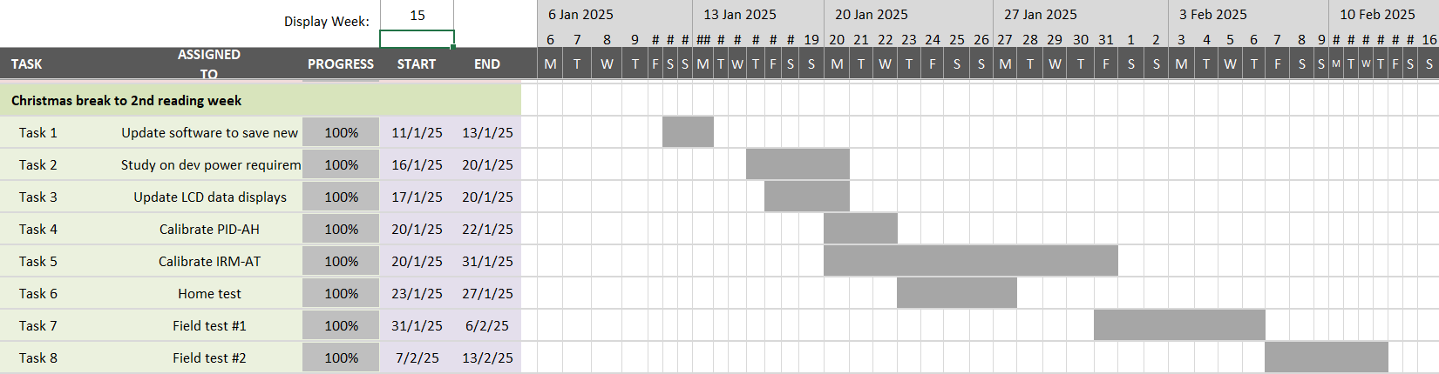

Figure 39 – Gantt Chart for Testing and Analysis Stage, Semester 2

This period was dedicated to the testing and analysis of the device to scrutinize its effectiveness and practicality and hence, to gauge how well it embodies the project objectives. The first tests implemented were basic sensor tests to ensure their functionality and accuracy of concentration measurement. Some sensors at this stage, specifically the alphasense gas sensors, had to also be calibrated through experiments (as explained in **Sections 6.3 & 6.4**). The achievement of calibrating the sensors were particularly significant as it gave me the opportunity to perform experiments beyond electronics engineering, and venture into the worlds of chemistry and data analysis, giving me invaluable experience for the future. Next, once all sensors were calibrated and outputting trustworthy pollutant concentrations, field testing in-situ could commence by using university connections to contact a willing farmer to utilise the project device on his farm. The importance of these tests cannot be understated as the resulting data in the form of concentration readings as well as positive feedback from the farmer provides undeniable evidence of the project goals being met. The experience gained at this stage was also priceless, giving me firsthand experience in communicating with end-users to aid in improving the device to meet non-functional requirements, and in data interpretation and presentation.